BBTalk -

BackBone Thesaurus
Submission and Connection Management tool

User Manual
Version 2.0

Korina Doerr
Christos Georgis
Konstantina Konsolaki
Evangelia Daskalaki
Martin Doerr

Status: Final DRAFT (under review)
Last Modified: 20 Sept 2018 (revision 11)

Institute of Computer Science
Foundation for Research and Technology – Hellas
Table of Contents
1. Introduction 6
2. User Roles 7
3. Signing-in & singing-up 8
4. Description of the user Interface 10
5. System Functionality 12
5.1 BackBone Thesaurus 12
5.1.1 BackBone Thesaurus – tree view 13
5.1.2 BBT term form - view mode 13
5.1.2.1 View an obsolete term 14
5.1.3 Search Term 15
5.1.4 Version control 16
5.1.4.1 Comparing versions 16
5.1.4.2 Creating a new BBT version 17
5.1.5 Edit BBT Properties 17
5.1.6 Generate RDF files 19
5.2 Submissions 19
5.2.1 Submission workflow and submission statuses 19
5.2.2 Submissions list description 21
5.2.2.1 Submissions List Filters 22
5.2.2.2 Submission Actions 23
5.2.3 Create a new submission 25
5.2.3.1 Submission form layout 25
5.2.3.2 Create a new submission for creating a new BBT term 27
5.2.3.3 Create a new submission for deleting a term 29
5.2.3.4 Create a new submission for modifying a term 29
5.2.3.5 Create a new submission for merging terms 31
5.2.3.6 Create a new submission for splitting a term 33
5.2.4 View a submission 35
5.2.4.1 Hide Changes in submissions 36
5.2.5 Commenting on submissions 37
5.2.6 Changing status in submissions 38
5.2.7 Forwarding a submission to a reviewer 39
5.2.8 Edit a submission 39
5.2.9 Search for submissions 40
5.3 Connections 41
5.3.1 Connections list description 41
5.3.1.1 Connections list filters 42
5.3.1.2 Connections actions 43
5.3.2 Create a new connection 44
5.3.2.1 Edit Thesaurus information 45
5.3.3 View a connection 46
5.3.4 Edit a connection 47
5.3.5 Search for connections 48
5.3.6 Exporting RDF files 49
5.4 Create a new BBT version 49
5.4.1 Load initial version of BBT 49
5.4.2 Inspect release terms 50
5.4.2.1 Release terms list filters 51
5.4.2.2 Release term form Actions 51
5.4.2.3 View a release term 52
5.4.2.4 Edit a release term 53
5.4.3 Preview new BBT version 54
5.4.4 Release new BBT version 55
5.5 Users 56
5.5.1 View and edit user profile information 56
5.5.2 Contact the system administrator 59
5.5.3 Users list 59

Table of Figures
Figure 1: Login Page 8
Figure 2: User Registration Form 9
Figure 3: Request New Password Form 10
Figure 4: Interface Description 11
Figure 5: BackBone thesaurus – tree view 12
Figure 6: BBT Term form – view mode 13
Figure 7: Obsolete term form 14
Figure 8: Search term form 15
Figure 9: Search term result table 16
Figure 10: BBT version comparison form 16
Figure 11: BBT version difference list 17
Figure 12: BackBone Thesaurus tool menu actions available to the administrator 17
Figure 13: Edit BBT Properties form 18
Figure 14: Sequence Diagram of submission statuses 20
Figure 15: List of Submissions 22
Figure 16: Submissions list filtered by keyword “ing” 23
Figure 17: Submissions list filtered by status “under discussion” 23
Figure 18: Submission list actions, depend on the submission status 24
Figure 19: Options for creating a new submission 25
Figure 20: Parts of the Submission form 26
Figure 21: Submission form for creating a new BBT term 27
Figure 22: Translation part of the Submission form for creating a new BBT term 28
Figure 23: Submission form for deleting a term 29
Figure 24: Submission form for modifying a term 30
Figure 25: Submission form for merging terms 32
Figure 26: Submission form for splitting a term 34
Figure 27: Submission form – view mode 36
Figure 28: Displaying changes in Submission form for modifying a term 37
Figure 29: Commenting on a submission 38
Figure 30: Change status in submissions 39
Figure 31: Select to edit a submission from submission form in view mode 39
Figure 32: Form for searching submissions 40
Figure 33: Connections list 41
Figure 34: Connections list filtered by keyword “acti” 42
Figure 35: Connections list actions (related to own connections) 43
Figure 36: Connections list actions (related to connections of other users) 43
Figure 37: Connection form (edit mode) 44
Figure 38: Thesaurus form 46
Figure 39: Connection form (view mode) 47
Figure 40: Connection Search Form 48
Figure 41: Exporting RDF files message 49
Figure 42: Create a new BackBone Thesaurus version - actions 49
Figure 43: Load Initial Thesaurus upload form 50
Figure 44: Release terms list results 50
Figure 45: Release terms list results: filtered by keyword “offi” 51
Figure 46: Release term form actions 52
Figure 47: Release term form – view mode 53
Figure 48: Release term form – edit mode 54
Figure 49: Preview new BBT version – tree view 55
Figure 50: Release new BBT version message 56
Figure 51: Account Settings option of the upper right menu 56
Figure 52: Account Settings form 57
Figure 53: Request to change User Role pop up screen 58
Figure 54: Change Password form 58
Figure 55: Contact Administrator pop up screen 59
Figure 56: Users list 59
Figure 57: Users list actions, available only the administrator 60
Figure 58: Change User Role 60

Introduction
What is the BackBone Thesaurus
The BackBone Thesaurus (hereafter called BBT) is an overarching thesaurus a coherent overarching thesaurus for the humanities, a “backbone” or “metathesaurus”, under which all the vocabularies and terminologies in use in the domain can be aligned. Therefore, this work focuses on identifying the top-level-terms (facets and hierarchies) that will become its common basis, meeting the demands for intersubjective and interdisciplinary validity. The proposed approach is bottom-up; top-level terms are developed by adequate abstraction from existing local terminological systems.
The BBT Submission and Connection Management tool functionalities
The BBT Submission and Connection Management tool (hereafter called BBTalk) is a communication system, developed by FORTH-ICS that supports discussions regarding the changes (related to facets, hierarchies and concepts) proposed for the current version of the BackBone Thesaurus, hereafter called submissions. It also supports the implementation of changes on BBT and the release of new BBT versions, based on related submissions, as well as the comparison between versions. Finally, the system allows local thesauri maintainers to connect their thesauri to the BBT.
In more detail, BBTalk provides the following functionalities:
(Related to submissions)
- Create submissions (suggesting changes for the BBT): it is used by local thesauri maintainers when they want to suggest changes for the BBT; it provides a form by which they can request modifications/additions/deletions regarding the terms of the thesaurus.
- Review submissions: it is used by the curators to browse and review submissions, and decide whether they agree, or disagree, to the suggested changes and implement/ reject/ postpone them.
It is also used by thesaurus reviewers that take part on specific change-related discussions.
- Forward submissions to reviewers: it allows curators to forward a submission to users that are experts in specific domains (reviewers), for further consultation.
- Keep track of submissions history: it keeps track of the history of the submissions (related past discussions).
- Notifications: it notifies all the interested parties, about the progress of a submission.
(Related to connections of local thesauri to the BBT)
- Assist connections of local thesauri to the BBT: it assists local thesauri maintainers to connect (and remove connections) their thesauri terms to BBT terms. Publishing a new version of the BBT may also affect the local thesauri that are connected to BBT, therefore local thesauri maintainers need to be notified.
- Notifications: it provides a notification mechanism that enables local thesauri maintainers to receive information about the release of the new version of the BBT.
(Related to new and past versions of BBT)
- Create new versions of BBT: it is used by the curators to implement changes in the BBT and create new versions of the BBT, based on the submissions and the following discussions.
- Provide access to previous BBT versions: facilitates the curators decisions by providing access to the previous versions of the thesaurus (along with the history of all the submissions)
- Compare BBT versions: it enables users to compare different versions of the BBT.
- Notifications: it notifies all the interested parties, about the release of the new version of the BBT.
(User management)
- User profile and contact info management: it provides users with the possibility to edit their personal profile information, as it also provides storage for user contact info.

User Roles
BBTalk can be accessed only with a valid username and password. Depending on the user’s role, the user will have different rights. The different user-roles supported by the system are:
- Contributors: The contributors are persons who wish to comment or suggest changes on the BBT, requesting additions, deletions or modifications on the BBT terms and their relations. Contributors can also be local thesauri maintainers who wish to link their local thesauri terms to terms in the BBT. Furthermore, contributor could be any person who is interested in browsing the BBT terms, their history of submissions and their connections with other thesauri terms.
- Curators: The curators are responsible for the maintenance of the BBT and the creation of new versions of BBT. Their role is to make changes to the thesaurus by consulting the submissions concerning the current and the previous versions of the thesaurus. They might also ask the consultancy of the thesaurus reviewers in order to take a decision about a specific change request. Curators can also act as contributors do: add submissions and connections, browse the BBT terms, their history of submissions and their connections.
- Reviewers: The reviewers review submissions forwarded by the curators that are pertinent to their expertise (domain of knowledge), and respond back to the curators with proposed changes to the BBT. Reviewers can also act as contributors do: add submissions and connections, browse the BBT terms, their history of submissions and their connections.
- Administrators: The system administrators are responsible for the maintenance of the system information and the system software: manage the new users, take and restore backups, etc. Administrators can act as curators do: maintaining the BBT and the creation of new versions of BBT, as well as add submissions and connections, browse the BBT terms, their history of submissions and their connections.
Users are welcome to sign up as is described in the following chapter.

Signing-in & singing-up
In the login page (Figure 1) the user has sign-in to the system using his/her username or e-mail and password. If the user is not registered to the system, he/she can request to sign up by creating a new account.
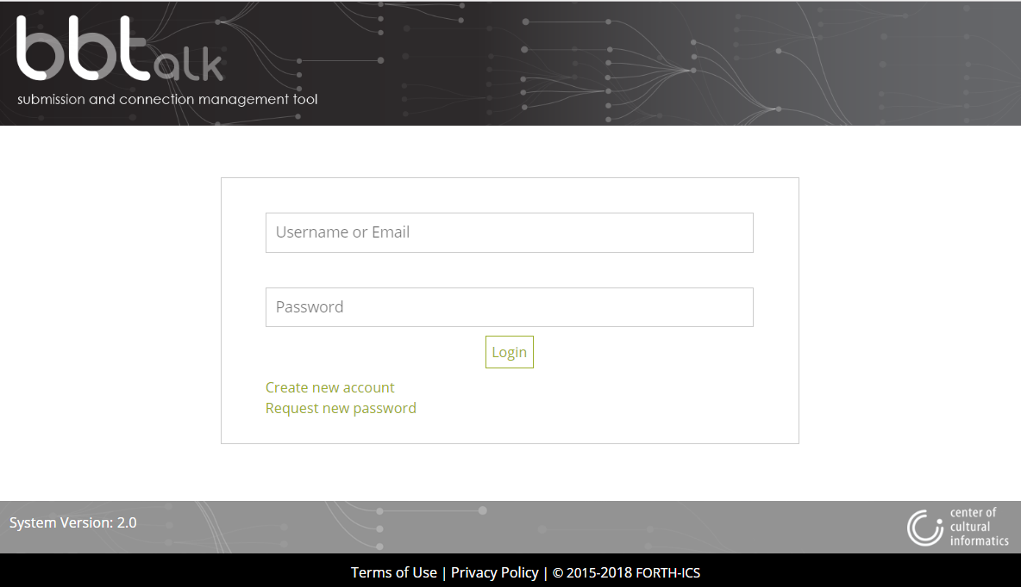
Figure 1: Login Page
The system will prompt a registration form (Figure 2) for acquiring user related information and registers the user under the role of contributor. The registration form contains the following fields:
- Username: This obligatory field denotes the name the user wants to be displayed in the system. Once given cannot be changed.
- New password: Add the new user password (obligatory field).
- Verify password: Verify that the new password is typed correctly (obligatory field).
- Firstname and lastname: User first and last name (not obligatory fields).
- E-mail address: The e-mail should be unique to the system (users cannot share the same e-mail address). The e-mail is used by the system, to verify the user existence (double opt-in) and in order to allow the system to send automatic messages to the user. This is an obligatory field.
- Institution: This field may contain information about the institution of the user (not obligatory field).
- Field of interest: This field may contain information about the research interests of the user (not obligatory field).
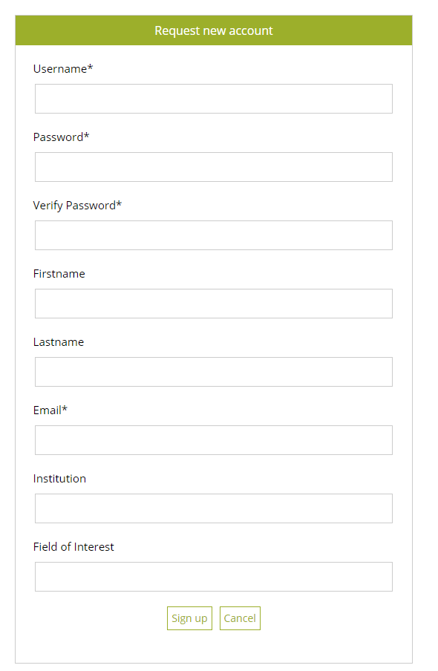
Figure 2: User Registration Form
Notice that this information (except Username) is considered personal information and is visible only to the user, the curators, the reviewers and the administrators, or used by the system without public display.
By selecting the “Sign up” button, the user receives a special confirmation e-mail in which he/she needs to confirm his/her wish to register to the system (double opt-in registration).
In case the user has an account, but he/she does not remember his/her password, a form is provided to re-assign a new password to the user (Figure 3). The system will send a new password to user’s e-mail address.
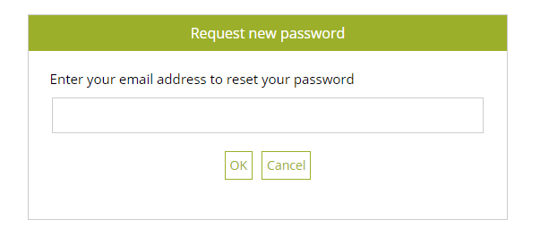
Figure 3: Request New Password Form

Description of the user Interface
Related user role: all (applies to the entire chapter apart from paragraphs with other indication in the beginning)
The main area of the system is divided in the following parts (Figure 4):
The header, which includes the upper right menu. The upper right menu includes the “About” section with a general introduction to the system, the “Help” section with the User Manual and a Quick User Guide options and the “User Account” section with Account Settings and Logout options.
The main menu is located under the header. The main menu contains four tab-sections: BackBone Thesaurus, Submissions, Connections and Users. Briefly, those tab-sections consist of the following content (the functionality provided by each tab-section is described in detail in the following chapter):
- BackBone Thesaurus tab includes the tree of terms of the BackBone Thesaurus. From the tree, the user can navigate to the term forms where he/she can find more information about each term. Here the user can also create a new connection or a new submission for change on a specific term. This tab also provides functionality related to the BBT versions (e.g. release a new version or compare two versions) and term-search based on specific criteria.
- Submissions tab includes a list of all submissions on the BBT terms. From this list the user can navigate to the submission forms where he/she can find more information about each submission and maybe leave a comment. Here the user can also create a new submission or search for a submission based on specific criteria.
- Connections tab includes a list of all connections made from the BBT terms to the terms of local thesauri. From this list the user can navigate to the connection forms where he/she can find more information about each connection. Here the user can also create a new connection or search for a connection based on specific criteria.
- Users tab (Related user role: curator, reviewer, administrator) includes a list of all user accounts. From this list only the curator, the reviewer, or the administrator can navigate to the user forms where he/she can find more information about each user. Here the administrator can also change the role of a user, or delete a user account.
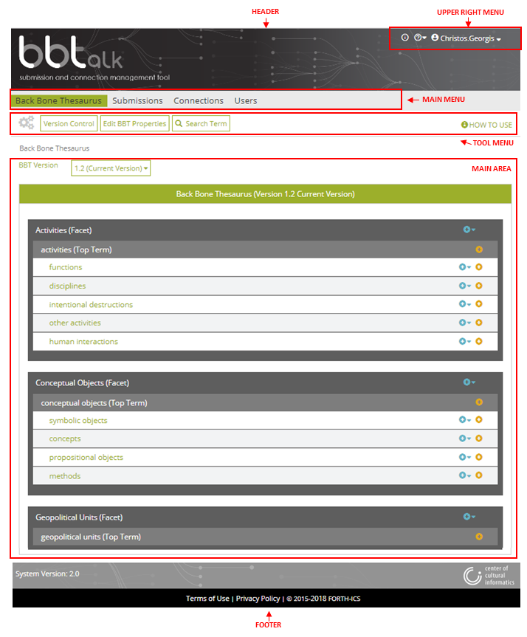
Figure 4: Interface Description
The content of the tab-sections described above appears in the main area of the system.
The tool menu is located on the top part of the main area. The tool menu includes buttons that support specific functions depending on the tab-section that is selected and the user role (e.g. in Figure 4, through the BackBone Thesaurus tab, “Version Control” and “Search Term” functions are available to all users, while “Edit BBT Properties” function is only available to the curators and the administrator). It also includes a “How to use” button where users can find information on how to use the specific tab-section.
The footer is located underneath the main area. In the footer the version of the system is displayed.

System Functionality

BackBone Thesaurus
Users can browse and search the terms of the official release of the BBT, as well as of older versions, using the BackBone Thesaurus tab-section. Users can also view differences between two BBT versions. Curators can also make changes to the BBT terms and facets, generate new versions of BBT, as well as edit BBT properties information.
Each term can be viewed by a term form with all the related information. It is possible to make submissions for changes on specific terms and additionally connect those terms with local thesaurus terms.
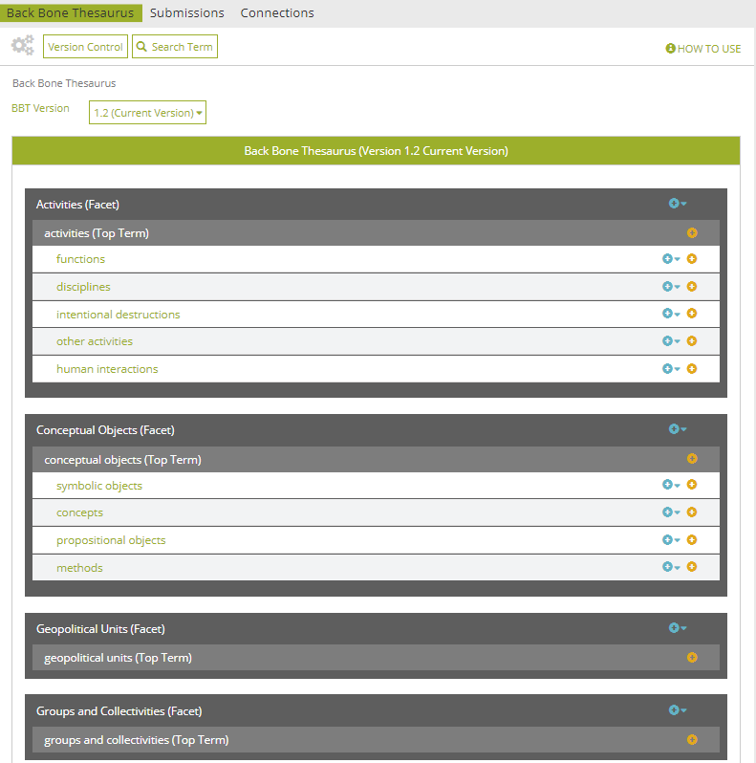
Figure 5: BackBone thesaurus – tree view
BackBone Thesaurus tab-section includes the following buttons: “Version Control” (see section “5.1.4 Version control”) and “Search Term” (see section “5.1.3 Search Term”) available to all users, “Edit BBT Properties” (see section “5.1.5 Edit BBT Properties”) available to the curators and the administrator and “Generate RDF files” (see section “5.1.6 Generate RDF files”) available only to the administrator. In Figure 5 above, the role of the current user is contributor.

BackBone Thesaurus – tree view
Related user role: all (applies to the entire section apart of paragraphs with other indication in the beginning)
When the BackBone Thesaurus tab-section is selected the tree of the BBT terms appears (Figure 5). “Facets” appear in a dark grey line, while the “top term” of the facet itself appear in a lighter grey line. All terms that belong under a facet (“hierarchies”), appear in a light colored line beneath the facet. All lines in the BBT tree are links that lead to the term forms. On the right side of each term line are placed two buttons: one for creating a new submission on the specific term (blue cross button) and one for creating a new connection with a local thesaurus term (orange cross button).

BBT term form - view mode
Related user role: all (applies to the entire section apart of paragraphs with other indication in the beginning)
In the tree of the BBT terms each line is a link that on click will lead to the BBT term form (Figure 6). A term form includes information related to the term such as: Label, URI, Scope Note, Facet, Broader, Narrower Term Examples.
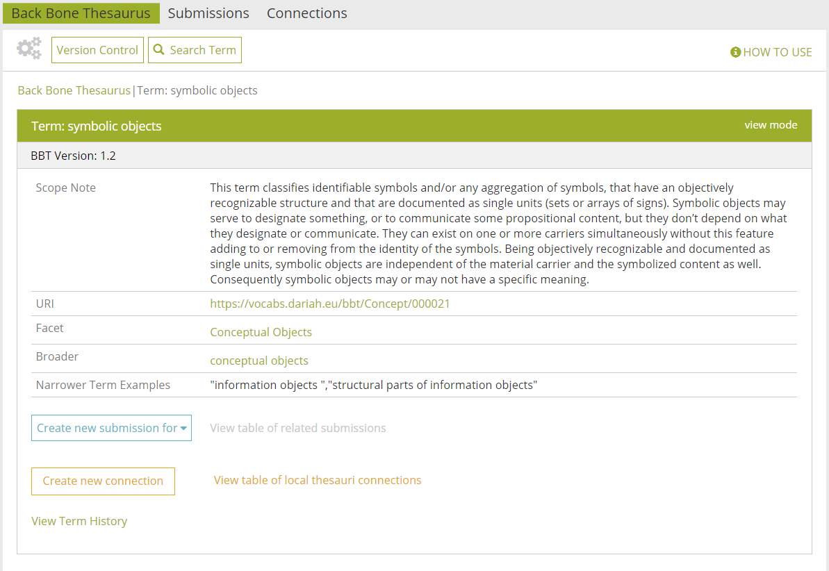
Figure 6: BBT Term form – view mode
Underneath the basic information are located the buttons for making a new submission to the specific term (described in detail in section “5.2.3 Create a new submission”), or for connecting the BBT term with a term of a local thesaurus (described in detail in section “5.3.2 Create a new connection”). Next to each button exists a link, which opens the list of all related submissions to the term and the list of all related connections respectively. Those lists are described in detail in sections “5.2.2 Submissions list description” and “5.3.1 Connections list description”.
Underneath the two buttons there is a link for displaying the history of the term. The changes in the displayed term version in comparison to older or newer term versions are presented in this area. The user is provided with links that lead term-forms displaying older or newer term versions.

View an obsolete term
Related user role: all (applies to the entire section apart of paragraphs with other indication in the beginning)
The system handles terms that existed in previous versions, but are not present in the current version of the BBT: they may be deleted terms or renamed terms, or even terms that were split or merged into other terms. Hereafter these terms are called obsolete terms.
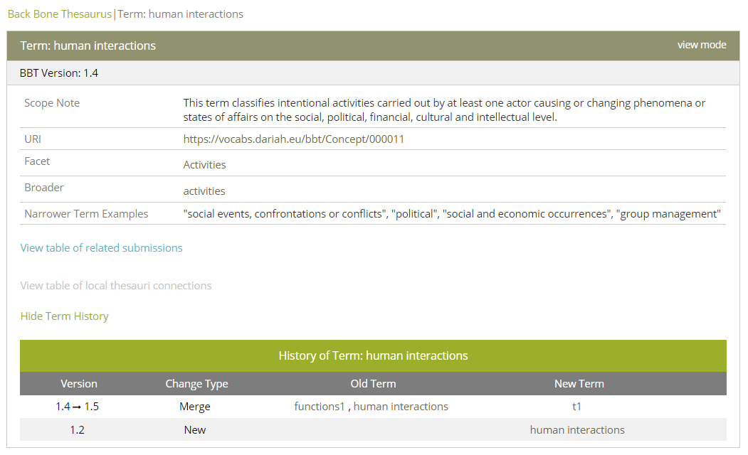
Figure 7: Obsolete term form
The system enable searching and displaying of obsolete terms. There is a special term-form for obsolete terms, colored with a de-saturated green color (Figure 7) that includes information related to the obsolete term such as: Label, Version, Scope Note, URI, Facet, Broader, Narrower Term Examples.
Below the basic information are located two links, which open the list of all related submissions to the term and the list of all related connections respectively (described in detail in sections “5.2.2 Submissions list description” and “5.3.1 Connections list description”).
Underneath, there is a third link for displaying the history of the obsolete term. The changes in the displayed obsolete term version in comparison to older or newer term versions are presented in this area. The user is provided with links that lead term-forms displaying older or newer term versions. In the fictional example of Figure 7, we see that term “human interactions” was introduced in v1.2, while in v1.5 the term was merged with term “functions1” to produce the new term “t1”.

Search Term
Related user role: all (applies to the entire section apart of paragraphs with other indication in the beginning)
The user may search the BackBone Thesaurus for terms (existing or obsolete) by name or IDs (URIs) in a selected version or in all BBT versions (Figure 8). The user can search for a term by adding the following criteria:
- Version
- Type of Term: facet or term
- BBT Term name
- BBT Term URI

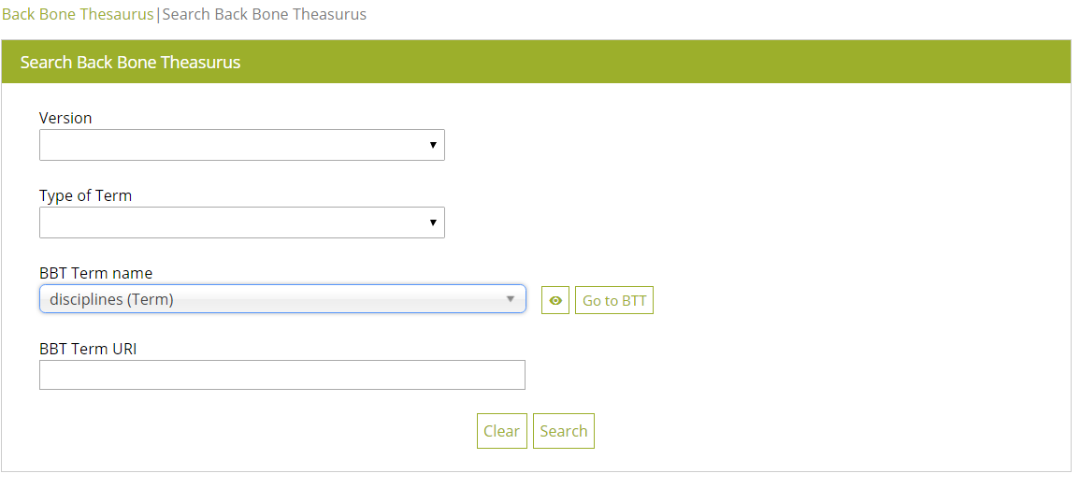
Figure 8: Search term form
The results of the search: the terms that match the criteria, appear in a list (Figure 9). Each line of the list represents a BBT term. Each column includes information related to the BBT term:
- Term Name: the name of the BBT term
- Term URI: the URI (ID) of the BBT term
- Type of Term: the type of the BBT term
- Version: the version of the BBT this term is part of
- Broader term the broader term of this BBT term
The terms under the columns: Term Name and Broader, provide links to BBT terms forms, presenting details of an existing term (in the current or of a past version) or an obsolete term.
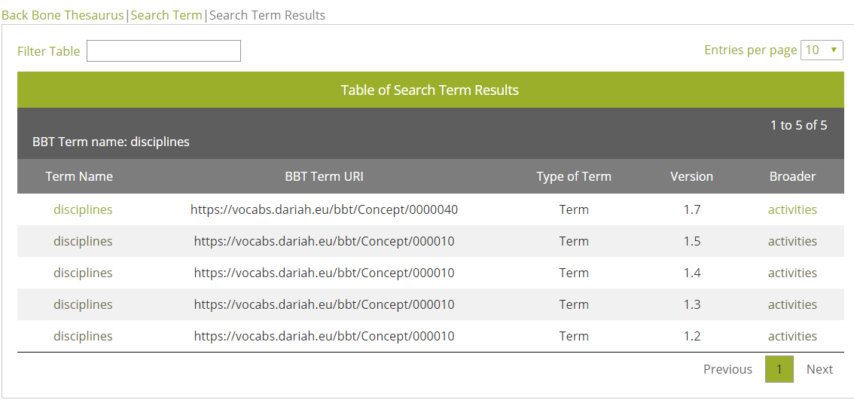
Figure 9: Search term result table

Version control
By selecting “Version Control” button from the BackBone Thesaurus tool menu the following actions are provided to the users: “View differences between BackBone Thesaurus versions” which is visible to all users and “Create a new BackBone Thesaurus version” which is visible only to the curators, the reviewers and the administrator.

Comparing versions
Related user role: all (applies to the entire section apart of paragraphs with other indication in the beginning)
The user may select a pair of versions of BBT and request a comparison (Figure 10). A list of the differences between the two versions appears in the main area (Figure 11).
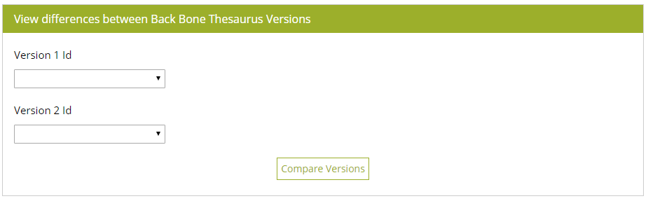
Figure 10: BBT version comparison form
In this list, the differences are listed by most recent version. Each line of the list represents a change in the thesaurus. Each column includes information related to the changes:
- Version: the version transition period that the change took place
- Change Type: the type of change (e.g. the change was splitting a term).
- Old Term: the terms involved before the change.
- New Term: the terms involved after the change.
Terms (old or new) in the change lines are links that lead to term-form of the specific version (old or new accordingly). Notice that in cases where terms appeared and disappeared within the same version transition period links are not available. The eye icon provides details on the specific term modification that took place.
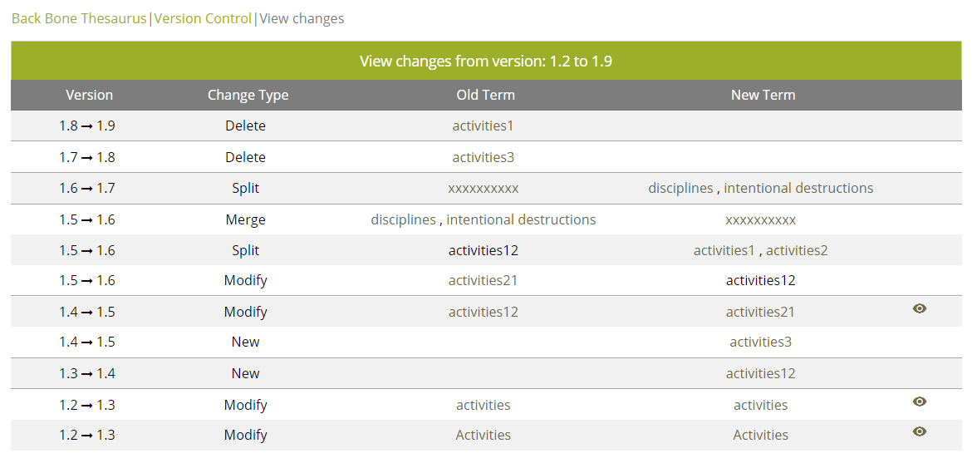
Figure 11: BBT version difference list

Creating a new BBT version
Related user role: curator, administrator (applies to the entire section apart of paragraphs with other indication in the beginning)
The curators and the administrator can make changes to the BBT terms and facets, generate new versions of BBT, as well as preview the new BBT version under construction before it is released. The administrator can re-initialize the thesaurus by uploading a RDF/SKOS file. This functionality is described in detail in section “5.4 Create a new BBT version”.

Edit BBT Properties
Related user role: curator, administrator (applies to the entire section apart of paragraphs with other indication in the beginning)
By selecting the “Edit BBT Properties” button from the BackBone Thesaurus tool menu (Figure 12) a form appears in the main area. In this form (Figure 13), the users can edit and modify BBT properties such as thesaurus title, author(s), description note, access rights, subjects, languages, etc.
Figure 12: BackBone Thesaurus tool menu actions available to the administrator
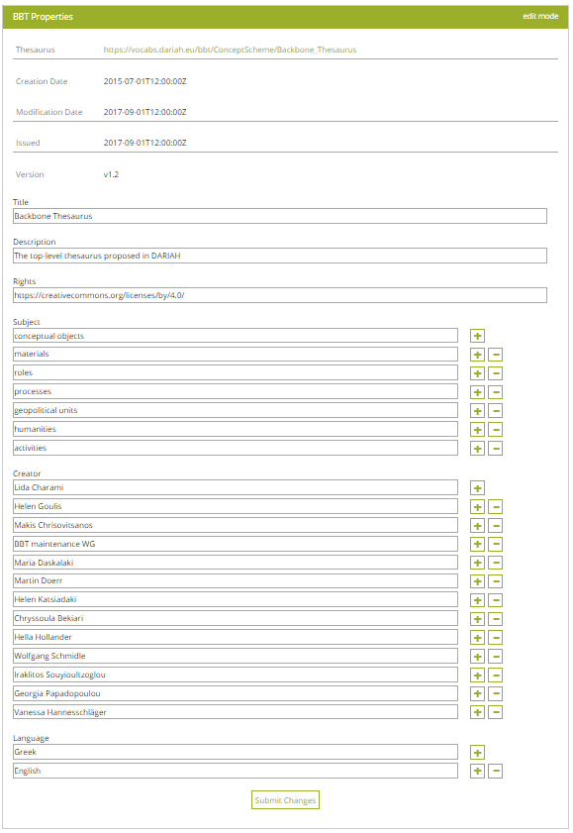
Figure 13: Edit BBT Properties form

Generate RDF files
Related user role: administrator (applies to the entire section apart of paragraphs with other indication in the beginning)
In order to keep BBTalk and BBT-browser synced, BBTalk automatically generates (e.g. on releasing a new BBT version or on administrator request) three files and makes them available (via specific URI locations) to the BBT-browser to ingest them and to its triple-store. These files are two RDF/SKOS files containing the current version of BBT, and the connections/mappings to all local thesauri concepts and an XML file containing the local thesauri access details.
By selecting the “Export RDF files” button from the BackBone Thesaurus tool menu the administrator can manually generate these files (Figure 12).

Submissions
Users can create a new Submission (request for change) for a BBT term, using Submissions tab-section. Users can also search, view and comment own and other user submissions or edit, delete own saved submissions.

Submission workflow and submission statuses
Related user role: all (applies to the entire section apart of paragraphs with other indication in the beginning)
In Figure 14 we present the sequence diagram of submission statuses. Contributors may decide to propose/request changes on the existing BackBone Thesaurus model by creating submissions. Their submissions can be either temporarily saved or submitted.
- saved: The user may save a submission, without submitting it. Submissions that have been saved and not submitted are registered as “saved”. Only the user sees his/her saved submissions and he/she may also delete them.
- submitted : Once the user sends a submission, the submission takes the status “submitted”. This status shows that the submission has not yet been checked from any curator. The user may delete his/her submission or change its status back to “saved” to be able to update the submission.
Curators may start a discussion (discussion-track) and add comments on the submission. All the curators may get involved in the discussion by adding their comments. They may need an expert opinion from a domain expert (reviewer), which can be invited to the discussion (by “Forward to Reviewer” action) or they may need clarifications from the submitter (by marking a specific comment as “Visible to the Submitter”), which this way is also invited to the discussion (see buttons in Figure 29). Note that not all comments of the discussion are visible to the submitter: he/she can only see specific comments, those marked by the curators (or the reviewers) as “Visible to the Submitter”.
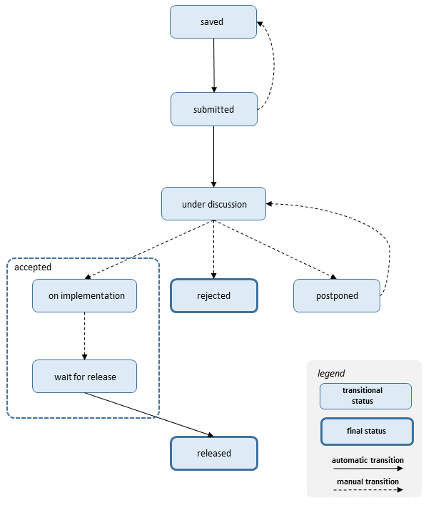
Figure 14: Sequence Diagram of submission statuses
- under discussion: After the submission is sent, a curator checks the submission and starts the discussion with other curators about the submission by adding comments to the submission. Now the submission is on a discussion-track and cannot be updated or deleted.
There is a case that the curator might need some explanations or even more information about the submission. If that is the case, the curator may ask the submitter (by adding a comment that is marked as “Visible to the Submitter”) or may ask a reviewer (by selecting the action ““Forward to Reviewer”). The submitter or the reviewer replies by adding a new comment, giving explanations or more information about the submission.
Related user role: curator, reviewer, administrator
The curators may finalize discussion or even pause/postpone the discussion. Finalizing a discussion on a submission means that the submission is either “rejected” or “released”. The curators may change the status of a submission to accepted/rejected/postponed. We intentionally keep the discussion open even when the submission is “on implementation” or is “waiting for release”, in order for the involved users to exchange opinions.
- (accepted) on implementation: When a submission has the status “on implementation”, means that the change request is in the phase of implementation.
- (accepted) wait for release: After the implementation is completed, the curator changes the submission status to “wait for release”. Related user role: contributor Notice that the contributors see the above two statuses as “accepted”.
- postponed: The request for change will be reviewed later in time.
- rejected: The request for change is considered as not implementable and all the parties are informed.
- released: When a new official version of the BBT model is released, all submissions with status “wait for release” change to “released” and all the interested parties are informed about the final status of the request for change.
Most statuses change automatically by the system when an action is executed, e.g. when a submitter saves or submits a request for a change (submission), the submission is registered as “saved” or “submitted” accordingly (Figure 14). Some statuses may change only the curator or administrator selecting “Change Status” button in the submission form (see section “5.2.6 Changing status in submissions”).

Submissions list description
Related user role: all (applies to the entire section apart of paragraphs with other indication in the beginning)
When the Submission tab-section is selected, the list of all submission entries appears in the main area (Figure 15). Submissions are listed by most recent entry date.
Each line of the list represents a submission. Each column includes information related to the submissions:
- Submission Type: the type of submission (e.g. proposal for splitting a term)
- Term Name: the term of the BBT the submission refers to
- Submitter: the user who made the submission
- Submission Date: the date of submission
- BBT Version: the version number of the BBT on which the submission was made
- Status: the status of the submission
- Submission Id: An identification number of the submission given automatically by the system
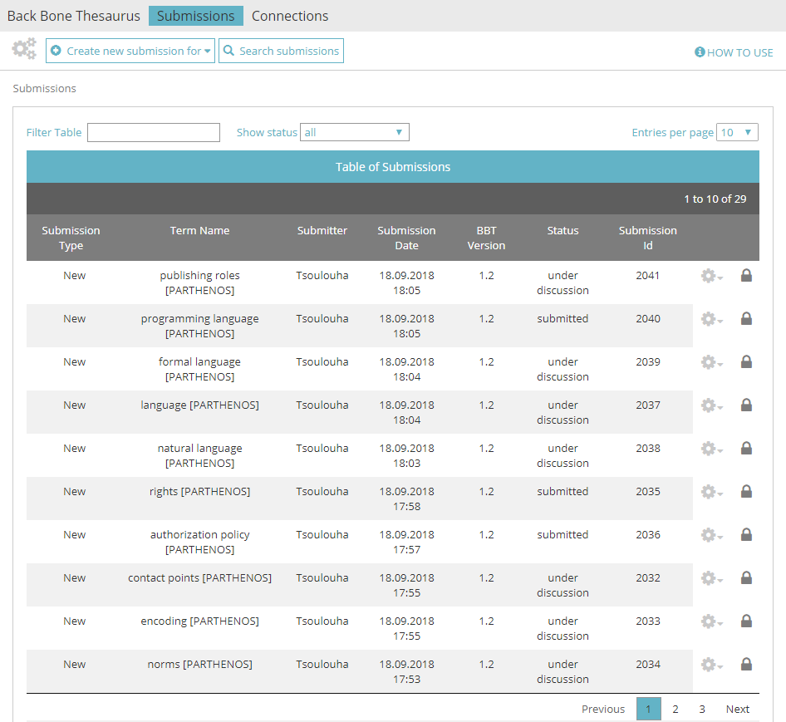
Figure 15: List of Submissions
All submission lines of the list are links that lead to the Submissions form in view mode (see section “5.2.4 View a submission”).
Submissions tab-section includes a “Create New Submission for…” button (see section “5.2.3 Create a new submission”) and a “Search Submissions” button (see section “5.2.9 Search for submissions”).

Submissions List Filters
The user can filter submissions either from the filter box on the left top side of the list using keywords related to the field content that appears in the columns and rows of the table (Figure 16) or from the dropdown list on the center top side of the list depending on their status (Figure 17).
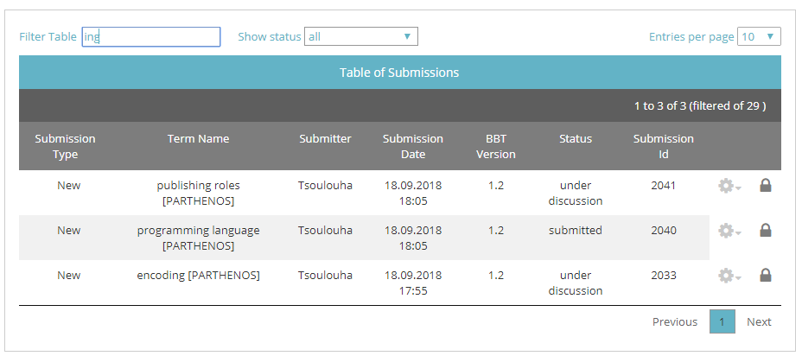
Figure 16: Submissions list filtered by keyword “ing”
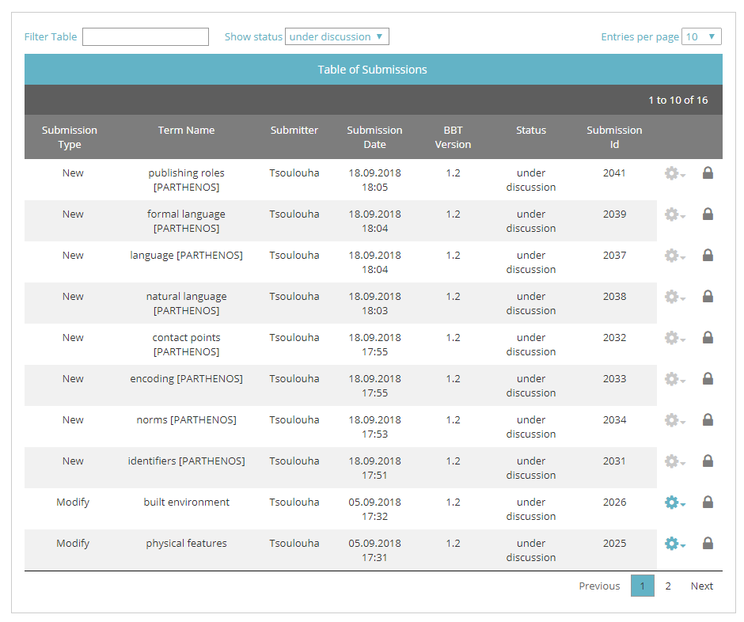
Figure 17: Submissions list filtered by status “under discussion”

Submission Actions
The user may select to edit or delete one of his/her own submissions, view the BBT term add a comment to a submission or forward the submission to a reviewer or the submitter.
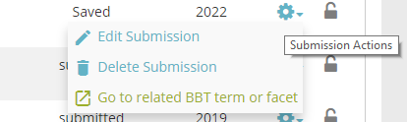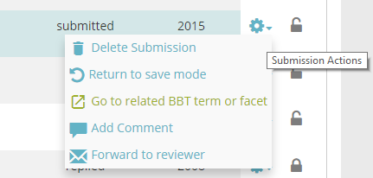
Figure 18: Submission list actions, depend on the submission status
On the right side of each submission line are located the action buttons (Figure 18). Notice that actions depend on the status of the submission and whether the user owns the submission:
- Edit Submission: (Related user role: owner) this button opens the submission form in edit mode. Users can only edit their own submissions and only those with status “saved”. (Related user role: administrator) Only the administrator have the right to edit other user submissions (with status “saved”).
- Return to save mode: (Related user role: owner) since users can only edit their own submissions with status “saved”, this button enables users to change the status of a submission from “submitted” back to “saved”. (Related user role: administrator) Only the administrator have the right to return other user submissions (with status “submitted”) to status “saved”.
- Delete submission: (Related user role: owner) this button allows the user to delete the submission. Users can delete only their own submissions (submissions with status “saved” or “submitted”). A warning message appears by clicking the button. (Related user role: administrator) Only the administrator have the right to delete other user submissions (submissions with status “saved” or “submitted”).
- Go to related BBT term or facet: (Related user role: all) this button allows the user to view the BBT term.
- Add a comment: (Related user role: all) this button opens the submission form in edit mode and reveals the submission discussion, thus enabling the user to add a comment in the discussion (see details in section “5.2.5 Commenting on submissions”).
- Forward to reviewer: (Related user role: curator, administrator) this button invites one or more reviewers to take part in a submission discussion. It opens up a pop up screen allowing the user to choose the specific reviewer(s) and to write an invitation message. The system therefore enables him/them to add comments to the submission. Additionally the system sends an e-mail to the reviewer(s), which includes the typed message, the link to the submission and the comment from the user (see details in section “5.2.7 Forwarding a submission to a reviewer”).
Notice that the same set of actions is available from the Submission form in view mode that is discussed in detail in section “5.2.4 View a submission”.

Create a new submission
Related user role: all (applies to the entire section apart of paragraphs with other indication in the beginning)
In order to create a new Submission, the user has to choose “Create new submission for…” from the top left side of the tool menu. The button expands a dropdown list with the types of submission actions available (Figure 19):
- Creating a new term: The user wants to request the addition of a new term to the BBT.
- Deleting a term: The user wants to request the deletion of an existing term of the BBT.
- Modifying a term: The user wants to request the modification of the name or the scope note (or any other related information) of an existing term of the BBT.
- Merging terms: The user wants to request the merge of two or three existing terms of the BBT.
- Splitting terms: The user wants to request the split of an existing term of the BBT into two separate terms.
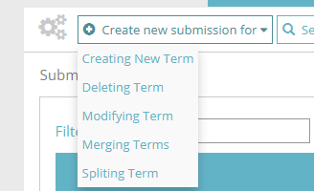
Figure 19: Options for creating a new submission

Submission form layout
The Submission forms vary depending on the submission type. The general structure is the same but some fields might differ.
The Submission form page is divided in the following parts (Figure 20):
- Breadcrumbs: They are located on the left top side of the page and help the user navigate back to the main page of the Submission tab-section.
- Form Title: In this area (in blue color) of the Submission tab-section the submission type is displayed (e.g. Submission for modifying term). On the right side of this arear the mode (edit/view) of the form is mentioned (here edit mode).
- Admin related Info: The area in grey color displays information such as: the username of the submitter, the submission date and the version of the BBT to which the referred BBT term belongs. These fields are not editable.
(BBT term related info, depends on the type of submission)
The main part of the page includes all the information that is related to the term. The fields included in this part depend on the submission type (splitting a term, delete a term etc.). These fields are described in detail in sections 5.2.3.2 to 5.2.3.6.
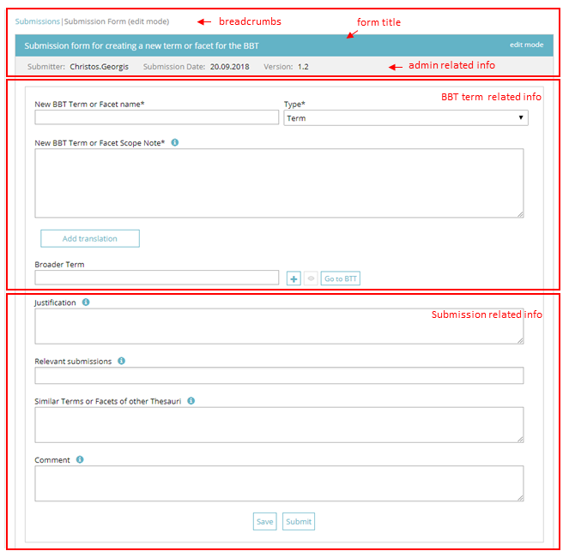
Figure 20: Parts of the Submission form
(Submission related info)
- Justification: In this free text field the user can add a justification about his/her submitted request for change.
- Relevant submissions: In this field related submissions can be added. More than one submissions can be linked.
- Similar Terms (or Facets) of other Thesauri: In this free text field the user can add similar terms of facets of other thesauri.
- Comment: In this free text field the user can add a comment in relation to the submission.
By using this “Save” the submission is saved and added to the table of submissions. Its status is marked as “saved”. These submissions can be edited or deleted and are only visible by their creator until they are submitted.
By using this “Submit” a submission is sent. Now it is visible to all user roles. Its creator has not anymore the right to edit the submission. Its status will be marked as “submitted” until it will be evaluated by the curators and the reviewers. These submissions can be deleted, only by their creators. They can also be declared as “saved” in case their creator wants to edit them.
Both the top and the bottom parts of the form contain what we call the general fields of the submission form.

Create a new submission for creating a new BBT term
Related user role: all (applies to the entire section apart of paragraphs with other indication in the beginning)
When choosing the (create new submission for) “Creating New Term” option the submission form for creating a new BBT term in edit mode appears. The submission form includes all the general fields described in section “5.2.3.1 Submission form layout”. Additionally the main /middle part of the submission form for creating a new BBT term, has the following specific fields (Figure 21):
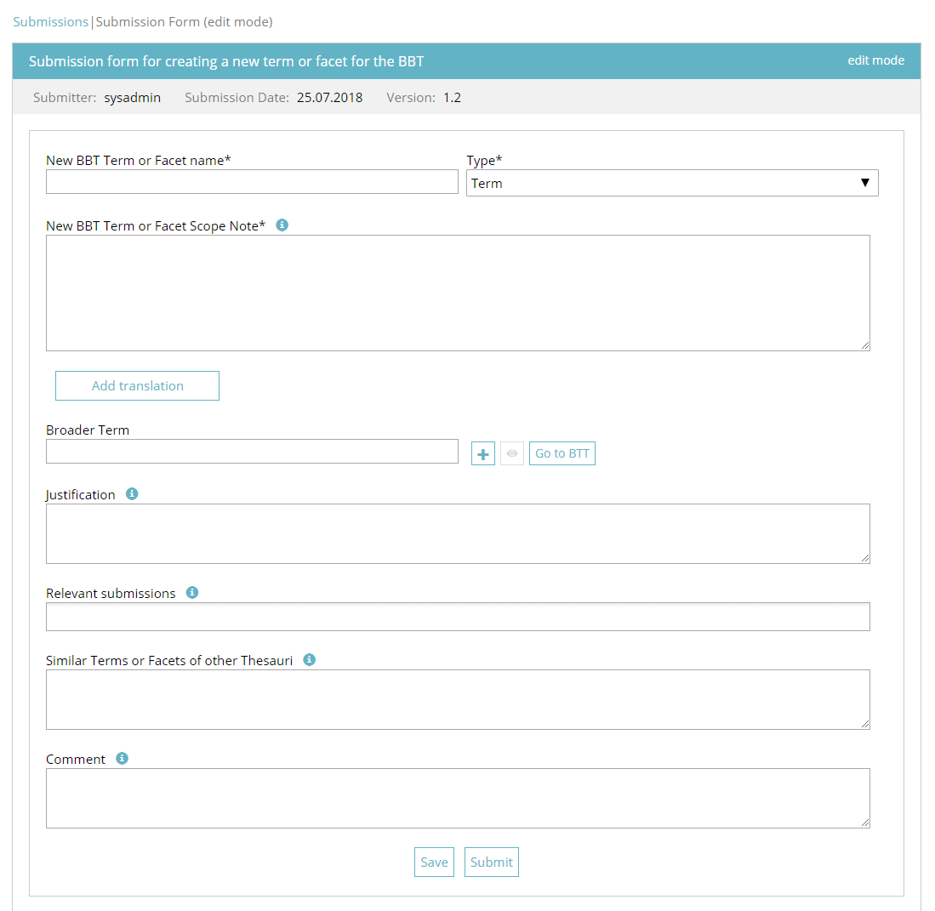
Figure 21: Submission form for creating a new BBT term
- New BBT Term or Facet name: In this field is added the name of the term or facet, which is requested to be added to the BBT. This field is obligatory.
- Type: In this field the type “term” or “facet” must be specified. This field is obligatory.
- New BBT Term or Facet Scope note: The scope note is the description of the term. This is a free text field. This field is obligatory.
- Broader term: In this field the user can add the broader term. This means, the BBT term that is above the new proposed term in the hierarchy of the BBT. Enter the first letter of the term and choose a BBT term from the dropdown list. More broader terms can be added by clicking on the “+” button. If the user wants to delete an extra broader term, he/she can click on the delete button next to the text field. If a BBT term is selected the view button is activated. This button opens up a pop up window with the BBT term form of the selected term. The user can also choose the “Go to BBT” button, which opens up a new tab in browser, in order to have a faster overview of the thesaurus (BackBone Thesaurus tab-section is selected).
By selecting “Add translation” button the user is prompted with a form to enter the translation of the new BBT term, for a specific language (Figure 22):
- Translation of new BBT Term or Facet name : In this field a translation of the new term can be added. This is a free text field.
- Language of translation: In this field the language of the translation of the new term is selected.
- Translation of new BBT Term or Facet Scope Note: In this field a translation of the scope note of the term can be added. This is a free text field.
Translation in multiple languages is allowed by selecting “Add translation” button for the next language. By pressing “x” button the selected translation is deleted.
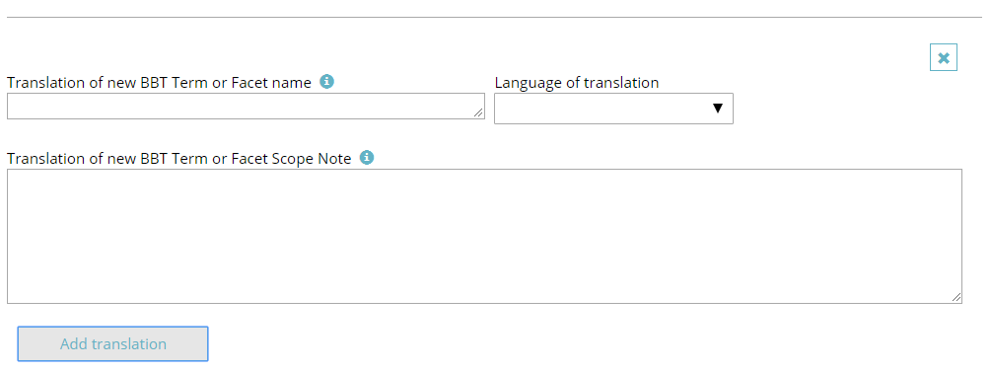
Figure 22: Translation part of the Submission form for creating a new BBT term

Create a new submission for deleting a term
Related user role: all (applies to the entire section apart of paragraphs with other indication in the beginning
When choosing the (create new submission for) “Deleting Term” option the submission form for deleting a BBT term in edit mode appears. The submission form includes all the general fields described in section “5.2.3.1 Submission form layout”. Additionally the main /middle part of the submission form for deleting a BBT term, has the following specific field (Figure 23):
- Choose the BBT Term of Facet you want to delete: In this field is added the name of the BBT term be deleted. Enter the first letter of the term and choose a BBT term from the dropdown list. If a BBT term is selected the view button is activated. This button opens up a pop up window with the BBT term form of the selected term. The user can also choose the “Go to BBT” button, which opens up a new tab in browser, in order to have a faster overview of the thesaurus (BackBone Thesaurus tab-section is selected). This field is obligatory.
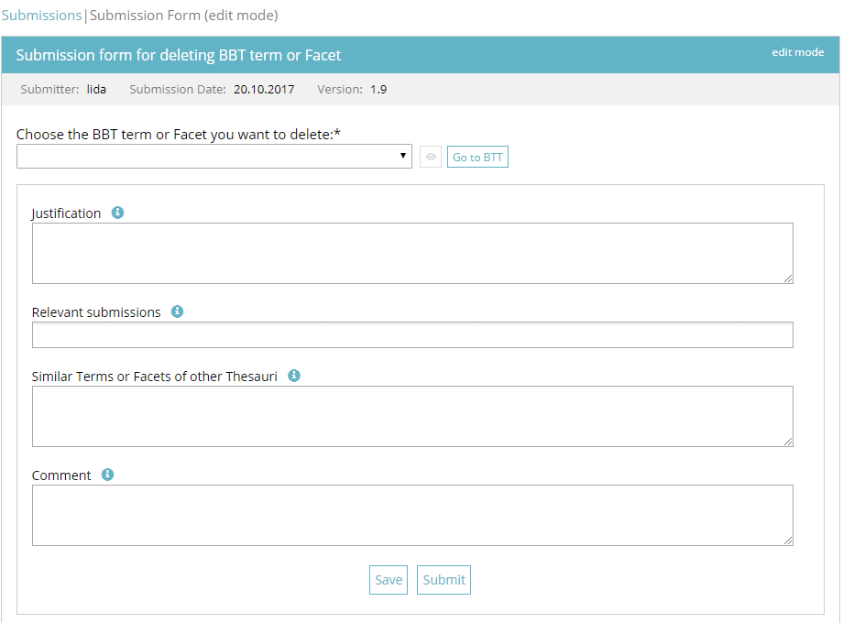
Figure 23: Submission form for deleting a term

Create a new submission for modifying a term
Related user role: all (applies to the entire section apart of paragraphs with other indication in the beginning)
When choosing the (create new submission for) “Modifying Term” option the submission form for modifying a BBT term in edit mode appears. The submission form includes all the general fields described in section “5.2.3.1 Submission form layout”. Additionally the main part of the submission form for modifying a BBT term, has the following specific fields (Figure 24):
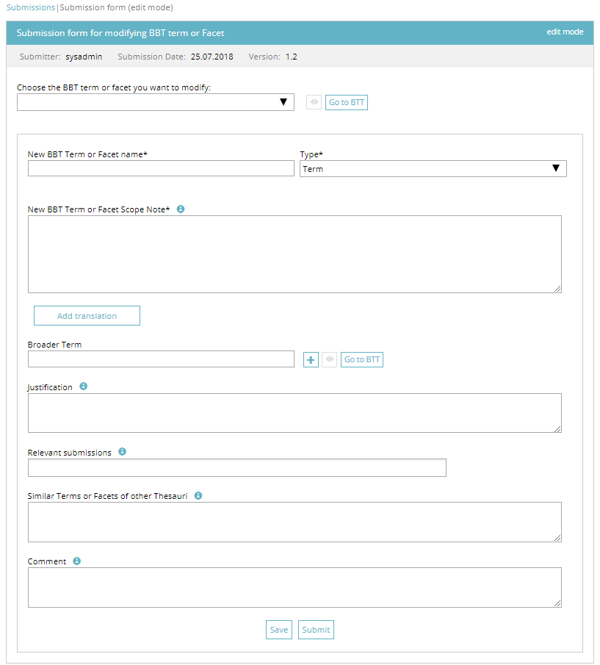
Figure 24: Submission form for modifying a term
- Choose the BBT Term of Facet you want to modify: In this field is selected the name of the term or facet, which is requested to be modified. Enter the first letter of the term and choose a BBT term from the dropdown list. If a BBT term is selected the view button is activated. This button opens up a pop up window with the BBT term form of the selected term. The user can also choose the “Go to BBT” button, which opens up a new tab in browser, in order to have a faster overview of the thesaurus (BackBone Thesaurus tab-section is selected). This field is obligatory.
Once the BBT term is selected all the information related to the term is filled automatically to the fields of the form, ready to be modified.
- New BBT Term or Facet name: In this field the name of the term or facet, can be modified. This field is obligatory.
- Type: In this field the type “term” or “facet” is specified. This field is obligatory.
- New BBT Term or Facet Scope note: The scope note is the description of the term. This is a free text field. This field is obligatory.
- Broader term: In this field the user can add the broader term. This means, the BBT term that is above the new proposed term in the hierarchy of the BBT. Enter the first letter of the term and choose a BBT term from the dropdown list. More broader terms can be added by clicking on the “+” button. If the user wants to delete an extra broader term, he/she can click on the delete button next to the text field. If a BBT term is selected the view button is activated. This button opens up a pop up window with the BBT term form of the selected term. The user can also choose the “Go to BBT” button, which opens up a new tab in browser, in order to have a faster overview of the thesaurus (BackBone Thesaurus tab-section is selected).
By selecting “Add translation” button the user is prompted with a form to enter the translation of the new BBT term, for a specific language (Figure 22):
- Translation of new BBT Term or Facet name: In this field a translation of the new term can be added. This is a free text field.
- Language of translation: In this field the language of translation of the new term is selected.
- Translation of new BBT Term or Facet Scope Note: In this field a translation of the scope note of the term can be added. This is a free text field.
Translation in multiple languages is allowed by selecting “Add translation” button for the next language. By pressing “x” button the selected translation is deleted.

Create a new submission for merging terms
Related user role: all (applies to the entire section apart of paragraphs with other indication in the beginning)
When choosing the (create new submission for) “Merging Terms” option the submission form for merging BBT terms in edit mode appears. The submission form includes all the general fields described in section “5.2.3.1 Submission form layout”. Additionally the main part of the submission form for merging BBT terms, has the following specific fields (Figure 25):
- Choose the BBT terms or Facets you want to merge: In this field, the user can add the terms or facets to be merged. Enter the first letter of the term and choose a BBT term from the dropdown list. More terms (up to three in total) can be added by clicking on the “+” button. If the user wants to delete an extra term he/she added, he/she can click on the “-“ button next to the third field. If a BBT term is selected the view button is activated. This button opens up a pop up window with the BBT term form of the selected term. The user can also choose the “Go to BBT” button, which opens up a new tab in browser, in order to have a faster overview of the thesaurus (BackBone Thesaurus tab-section is selected). By pressing the “Auto fill content” button all the information related to the selected terms is entered automatically to the fields of the form, ready to be modified. This field is obligatory (at least two terms must be selected).
- New BBT Term or Facet name: In this field is added the name of the term or facet, which is requested to be added to the BBT. This field is obligatory.
- Type: In this field the type “term” or “facet” must be specified. This field is obligatory.
- New BBT Term or Facet Scope note: The scope note is the description of the term. This is a free text field. This field is obligatory.
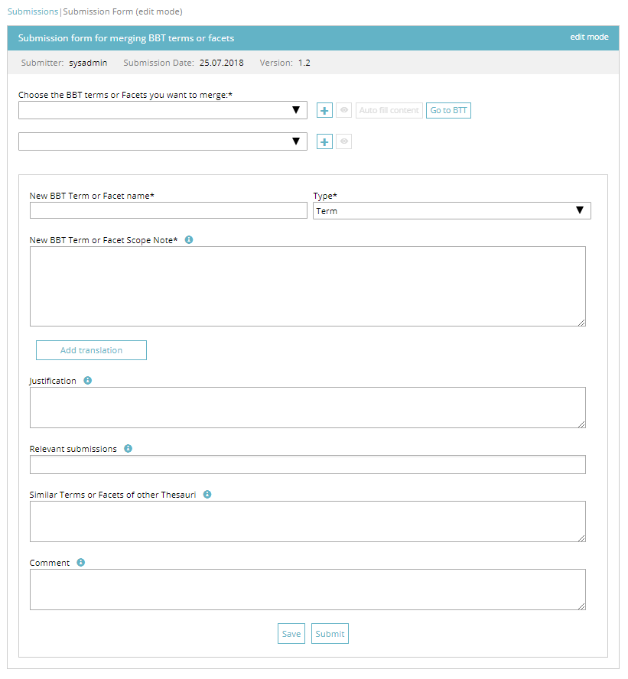
Figure 25: Submission form for merging terms
By selecting “Add translation” button the user is prompted with a form to enter the translation of the new BBT term, for a specific language (Figure 22):
- Translation of new BBT Term or Facet name: In this field a translation of the new term can be added. This is a free text field.
- Language of translation: In this field the language of translation of the new term is selected.
- Translation of new BBT Term or Facet Scope Note: In this field a translation of the scope note of the term can be added. This is a free text field.
Translation in multiple languages is allowed by selecting “Add translation” button for the next language. By pressing “x” button the selected translation is deleted.

Create a new submission for splitting a term
Related user role: all (applies to the entire section apart of paragraphs with other indication in the beginning)
When choosing the (create new submission for) “Splitting Term” option the submission form for splitting a BBT term in edit mode appears. The submission form includes all the general fields described in section “5.2.3.1 Submission form layout”. Additionally the main part of the submission form for splitting a BBT term, has the following specific fields (Figure 26):
- Choose the BBT term or facet you want to split: In this field is selected the name of the term or facet, which is requested to be split. Enter the first letter of the term and choose a BBT term from the dropdown list. If a BBT term is selected the view button is activated. This button opens up a pop up window with the BBT term form of the selected term. The user can also choose the “Go to BBT” button, which opens up a new tab in browser, in order to have a faster overview of the thesaurus (BackBone Thesaurus tab-section is selected). By pressing the “Auto fill content” button all the information related to the selected term is entered automatically to the fields of the form, ready to be modified. This field is obligatory.
The term is requested to be split into the two following terms:
Information related to the term (1)
- New BBT Term or Facet name (1): In this field is added the name of the first term or facet, which is requested to be added to the BBT. This field is obligatory.
- Type (1): In this field the type “term” or “facet” must be specified. This field is obligatory.
- New BBT Term or Facet Scope note (1): The scope note is the description of the term. This is a free text field. This field is obligatory.
By selecting “Add translation” button the user is prompted with a form to enter the translation of the new BBT term (1), for a specific language (Figure 22):
- Translation of new BBT Term or Facet name (1): In this field a translation of the new term can be added. This is a free text field.
- Language of translation: In this field the language of translation of the new term is selected.
- Translation of new BBT Term or Facet Scope Note (1): In this field a translation of the scope note of the term can be added. This is a free text field.
Translation in multiple languages is allowed by selecting “Add translation” button for the next language. By pressing “x” button the selected translation is deleted.
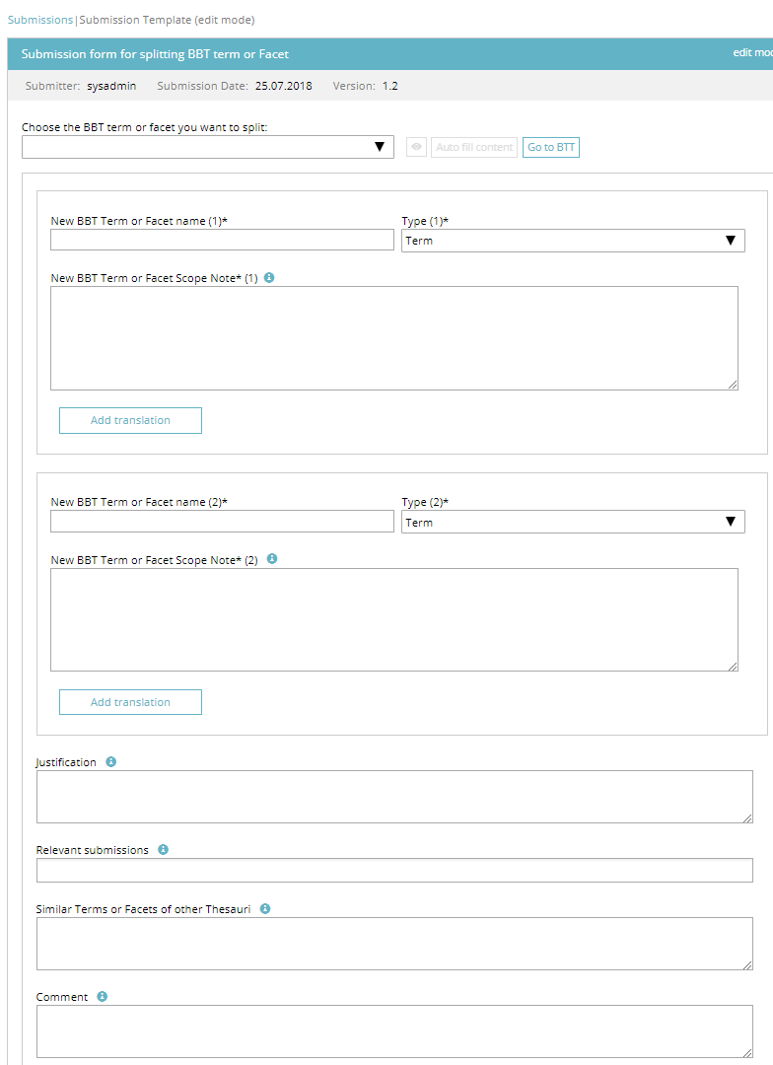
Figure 26: Submission form for splitting a term
Information related to term (2)
- New BBT Term or Facet name (2): In this field is added the name of the second term or facet, which is requested to be added to the BBT. This field is obligatory.
- Type (2): In this field the type “term” or “facet” must be specified. This field is obligatory.
- New BBT Term or Facet Scope note (2): The scope note is the description of the term. This is a free text field. This field is obligatory.
By selecting “Add translation” button the user is prompted with a form to enter the translation of the new BBT term (2), for a specific language (Figure 22):
- Translation of new BBT Term or Facet name (2): In this field a translation of the new term can be added. This is a free text field.
- Language of translation: In this field the language of translation of the new term is selected.
- Translation of new BBT Term or Facet Scope Note (2): In this field a translation of the scope note of the term can be added. This is a free text field.
Translation in multiple languages is allowed by selecting “Add translation” button for the next language. By pressing “x” button the selected translation is deleted.

View a submission
Related user role: all (applies to the entire section apart of paragraphs with other indication in the beginning)
When choosing a row of the table (which is a link to a specific submission) the submission form in view mode opens up (Figure 27).
The submission form page is divided in the following parts (described also in section “5.2.3.1 Submission form layout”):
- The top part which includes the breadcrumbs, the form title and the admin related Info, such as: the username of the submitter, the submission date, the version of the BBT, the submission ID, etc.
- The main part of the page includes all the information that is related to the term. The fields included in this part depend on the submission type (splitting a term, delete a term etc.). These fields are described in detail in sections 5.2.3.2 to 5.2.3.6.
- Finally the bottom part that includes all the submission related information, such as the justification, any relevant submissions and any similar terms (or facets) of other thesauri.
At the bottom of the form are located action buttons related to the submission. Notice that actions depend on the status of the submission and whether the submission is owned by the user. The actions are discussed in detail in section “5.2.2.2 Submission Actions”.
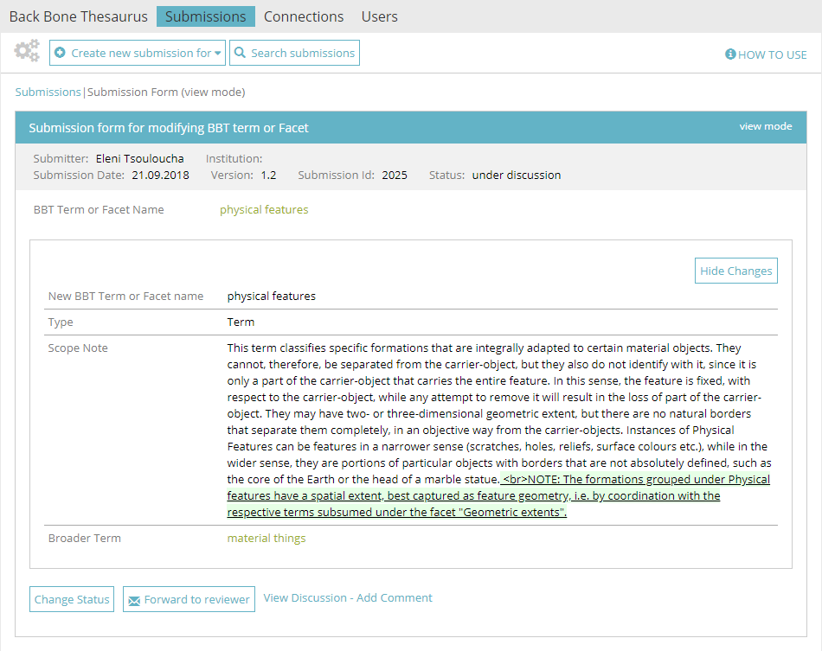
Figure 27: Submission form – view mode
“View Discussion - Add comment” link enables the user to view the submission discussion and enables him/her to add a new comment (as described in section “5.2.5 Commenting on submissions”).
In the following sections we discuss in more detail “Hide Changes” button (section “5.2.4.1 Hide Changes in submissions”), “Change Status” button (section “5.2.6 Changing status in submissions”) and “Forward to Reviewer” button (section “5.2.7 Forwarding a submission to a reviewer”).

Hide Changes in submissions
Related user role: all (applies to the entire section apart of paragraphs with other indication in the beginning)
The users may choose to display or hide the changes in submission regarding the modification of a BBT term or Facet. Changes are made visible with special markup format: added text is highlighted in green and underlined, while deleted text is highlighted in light red and strikethrough (Figure 28). The user may select “Hide Changes”, to hide the markup, or by selecting “Show Changes” to make the markup visible again.
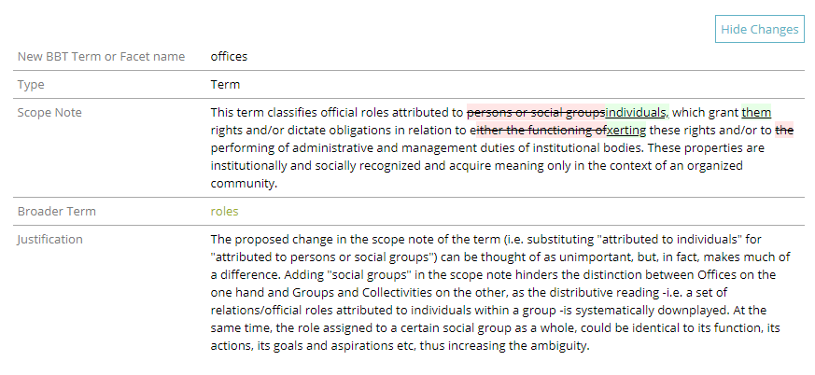
Figure 28: Displaying changes in Submission form for modifying a term

Commenting on submissions
Related user role: all (applies to all the section apart of paragraphs with other indication in the beginning)
There are two ways the user can view a submission discussion and get involved in it by adding a new comment: (a) by selecting a submission in the table of submissions and choose the “Add Comment” button (Figure 18) on the right side of the table row (also described in section “5.2.2.2 Submission Actions”) and (b) by selecting the “View Discussion – Add Comment” link in the Submission form in view mode (Figure 27).
By selecting “View Discussion – Add Comment” action the lower part of the Submission form (view mode) expands and reveals the discussion area (Figure 29). All users that are able to view the discussion can add a comment. The system automatically attaches to the comment, the username and the date the comment was made. The user can delete his/her last comment (before it is answered by a curator). A warning message will appear before the deletion.
(Related user role: curator, reviewer, administrator): The curator or the reviewer can select if the comment should be visible to the submitter (contributor). They may invite the contributor to give a clarification, or an explanation, by selecting the tick-box “Visible to the Submitter” on a new comment. The invitation of a contributor in a discussion is also discussed in section “5.2.1 Submission workflow and submission statuses”.
(Related user role: contributor): The contributors can only see the comments marked as “Visible to the Submitter” in the discussions under their own submissions
Curators may invite a reviewer or a contributor in a discussion (also discussed in detail in section “5.2.1 Submission workflow and submission statuses”).
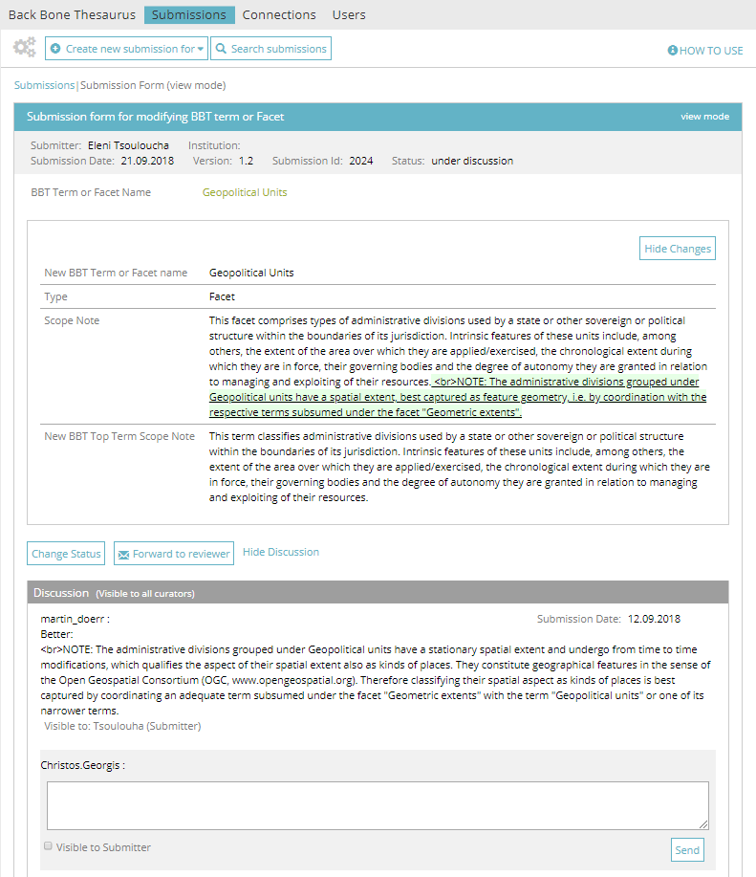
Figure 29: Commenting on a submission

Changing status in submissions
Related user role: curator, administrator (applies to the entire section apart of paragraphs with other indication in the beginning)
The users may finalize discussion or even pause/postpone the discussion, by selecting “Change Status” button in the Submission form (Figure 30). Finalizing a discussion on a submission means that the submission is either “rejected” or “released”. The users may change the status of a submission to accepted/rejected/postponed, as is described in section “5.2.1 Submission workflow and submission statuses”.
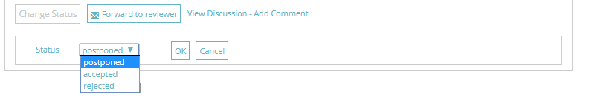
Figure 30: Change status in submissions

Forwarding a submission to a reviewer
Related user role: curator, administrator (applies to the entire section apart of paragraphs with other indication in the beginning)
The user can invite a reviewer to a discussion about a submission. This is possible by selecting the “Forward to Reviewer” button (from the Submission form) or the “Forward to Reviewer” action (from the Submissions list). This opens up a pop up screen allowing the user to write a message and choose the specific reviewer(s).
The system therefore enables the specific reviewer(s) to take part in the submission discussion (enables him/them to add comments to the submission). Additionally the system sends an e-mail to the reviewer(s), which includes the typed message, the link to the submission and the comment from the user.
The invitation of a reviewer in a discussion is also described in detail in section “5.2.1 Submission workflow and submission statuses”.

Edit a submission
Related user role: owner (applies to all the section apart of paragraphs with other indication in the beginning)
There are two ways the submitter can edit a submission: (a) by selecting a submission in the table of submissions and choose the “Edit Submission” button (Figure 18) on the right side of the table row (also described in section “5.2.2.2 Submission Actions”) and (b) by selecting the “Edit Submission” button in the Submission form in view mode (Figure 31).
Notice that editable are only the submissions owned by the user and are under status “saved”.
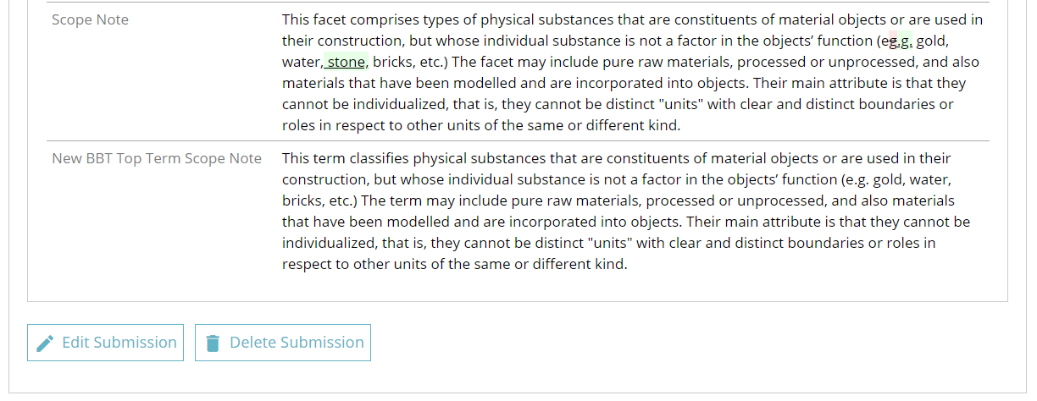
Figure 31: Select to edit a submission from submission form in view mode
When the submission form in edit mode appears, all fields are filled with information from the selected submission. A detailed description of the form can be found in section “5.2.3 Create a new submission”.

Search for submissions
Related user role: all (applies to all the section apart of paragraphs with other indication in the beginning)
The user may search for a submission by adding the following criteria ( Figure 32):
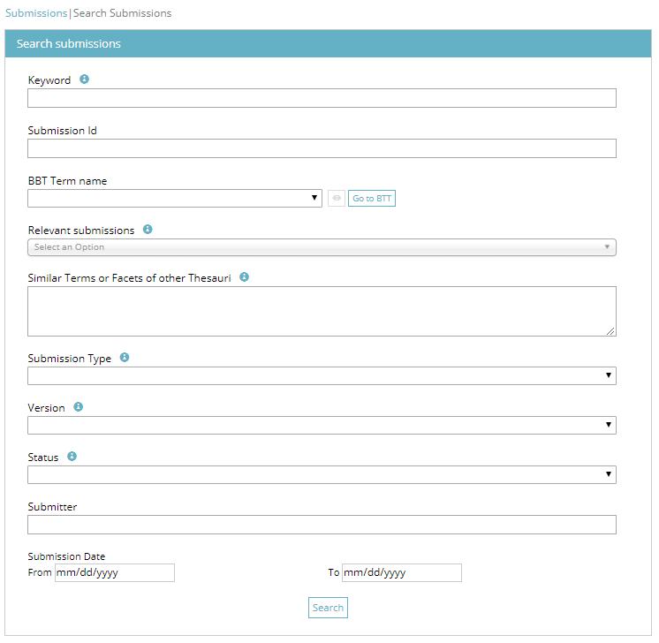
Figure 32: Form for searching submissions
- Keyword (anywhere in the submission text fields)
- Submission Id
- BBT Term Name
- Relevant Submissions
- Similar Terms or Facets of other Thesauri
- Action
- Version
- Status
- Submitter
- Submission date

Connections
Users can create a connection between a BBT term and a term of their local thesaurus, using Connections tab-section. Users can also search and view connections of other users as well as send a message to the connection creator. It is also possible for the user to edit or delete connections that he/she owns.

Connections list description
Related user role: all (applies to all the section apart of paragraphs with other indication in the beginning)
When the Connection tab-section is selected, the list of all connections /mappings appears in the main area (Figure 33). Connections are listed by most recent entry date.
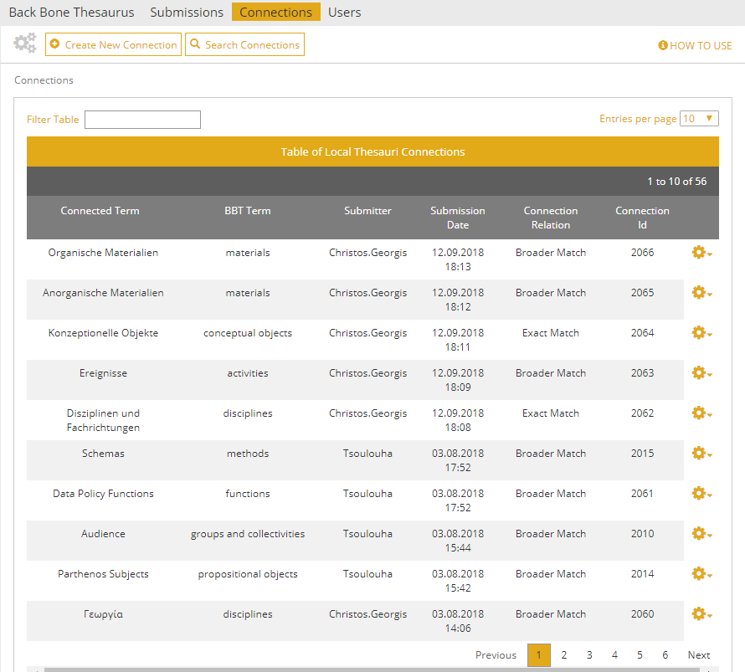
Figure 33: Connections list
Each line of the list represents a connection of a BBT term to a term of a local thesaurus. Each column includes information related to the connections:
- Connected Term: The name of the Local thesaurus term that is connected to the BBT term
- BBT Term: The name of the BBT term to which the Local Thesaurus term is connected.
- Submitter: the person who made the connection
- Submission Date: the date when the connection was made
- Connection relation: displays how the BBT term is related to the Local thesaurus term
- Connection Id: An identification number of the connection form given automatically by the system
All connection lines of the list are links that lead to the Connection form in view mode (see section “5.3.3 View a connection”).
Connections tab-section includes a “Create New Connection” (see section “5.3.2 Create a new connection”) and a “Search Connections” button (see section “5.3.5 Search for connections”).

Connections list filters
Related user role: all (applies to all the section apart of paragraphs with other indication in the beginning)
The user can filter connections from the filter box on the left top side of the list using keywords related to the field content that appears in the columns and rows of the table (Figure 34).
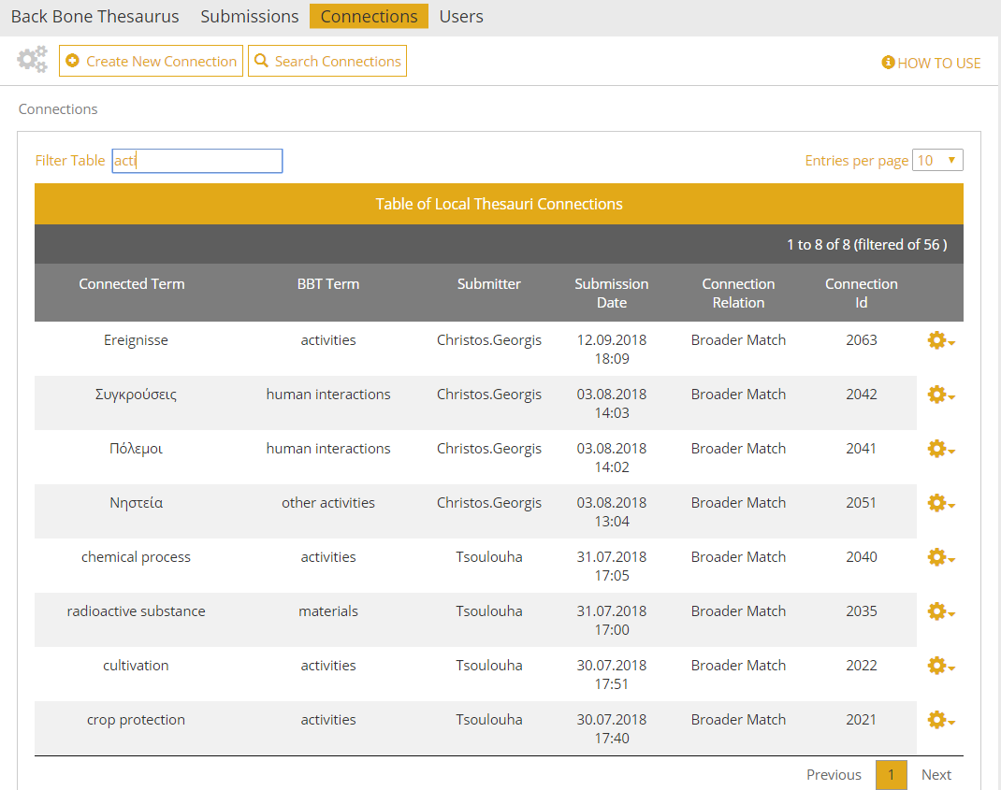
Figure 34: Connections list filtered by keyword “acti”

Connections actions
Related user role: all (applies to all the section apart of paragraphs with other indication in the beginning)
The user may select to edit or delete one of his/her own connections or view the BBT term. On the right side of each connection line are the related buttons (Figure 35):
- Edit Connection: (Related user role: owner) this button opens the edit mode of the connection form. Users can only edit their own connections.
- Delete Connection: (Related user role: owner) this button allows the user to delete the connection. Users can delete only their own connections. A warning message will appear by clicking the button. (Related user role: administrator) Only the administrator have the right to delete any connection.
- Export Thesaurus Connection RDF: (Related user role: all) this button allows the user to export one or more connection(s)/mapping(s) from a specific local thesaurus to BBT concept(s) in an RDF/SKOS file (discussed in detail in section “5.3.6 Exporting RDF files”).
- Go to related BBT term or facet: (Related user role: all) this button allows the user to view the BBT term.
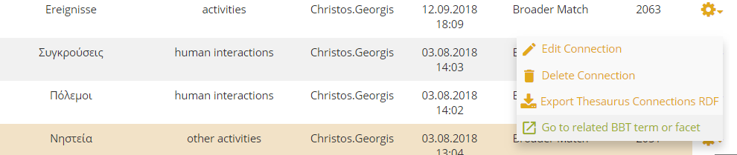
Figure 35: Connections list actions (related to own connections)
The user may select to send messages to other users related to their connections. On the right side of a connection line are the related buttons (Figure 36):
- Send message to Submitter: (Related user role: all) this button sends a message to the person that created the connection. It opens up a pop up screen allowing the user to write his/her message. The message includes a link to the connection form and the comment of the user. This action is available to all users.
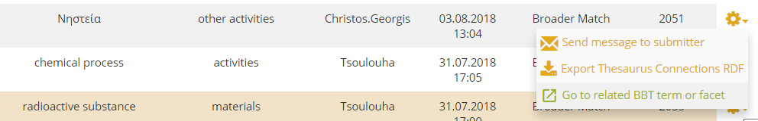
Figure 36: Connections list actions (related to connections of other users)
Notice that the same set of actions is available from the Connection form in view mode that is discussed in detail in section “5.3.3 View a connection”.

Create a new connection
Related user role: all (applies to all the section apart of paragraphs with other indication in the beginning)
In order to create a new Connection, the user has to choose “Create new connection” button from the top left side of the tool menu. The button opens up the connection form in edit mode (Figure 37).
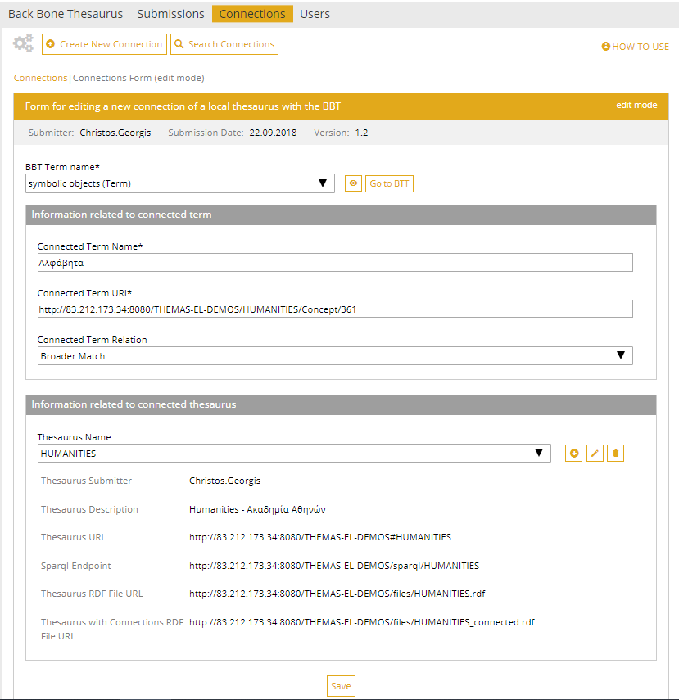
Figure 37: Connection form (edit mode)
The connection form page is divided in the following parts:
- Breadcrumbs: They are located on the left top side of the page and help the user navigate back to the main page of the Connections tab-section.
- Form Title: On the right side of this area (in the orange color) the mode (edit/view) of the form is mentioned (here edit mode).
- Admin related Info: The area in grey color displays information such as: the username of the creator of the connection, the date of the creation of the connection and the version of the BBT to which the referred BBT term belongs. These fields are not editable.
(BBT term related info)
- BBT Term name: Here the name of a BBT term must be added. Enter the first letter of the term and choose a BBT term from the dropdown list. This field is obligatory.
(info related to the term of the local thesaurus and its relation to the BBT term)
- Connected Term name: In this field the name of the term to be connected to the BBT term, is added. This field is obligatory.
- Connected Term URI: In this field the URI of the term to be connected to the BBT term, is added. This is the URI of the term in the local thesaurus. This field is obligatory.
- Connected Term Relation: In this field the type relation that the connected term (term to be connected) has with the BBT term, is added. It can have one of the two values: Broader Match, Exact Match.
(local thesaurus related info)
- Thesaurus name: In this field the name of the local thesaurus to which the connected term belongs can be selected. This is a controlled vocabulary field. By typing the first letter of the thesaurus, a list of thesauri names appears in a dropdown list. If the thesaurus name does not exist in the list, the user can add a new Thesaurus. The user can also modify or delete a thesaurus name from the list. This functionality is described in detail in section “5.3.2.1 Edit Thesaurus information”.
- All other thesaurus related information fields such as thesaurus submitter, thesaurus description, thesaurus URI, etc. are also described in detail in section “5.3.2.1 Edit Thesaurus information”.
By using the “Save” button the connection form information is saved and added to the list of connections.

Edit Thesaurus information
Related user role: thesaurus submitter, administrator (applies to all the section apart of paragraphs with other indication in the beginning)
The user that creates a connection can also add, edit or delete a thesaurus name and its related information. If the thesaurus name does not exist in the list, the user can choose “Add New Thesaurus” (cross icon) button at the right side of the field (Figure 37). If the user wants to modify or to delete a thesaurus name (and its related information) then he/she can choose an existing name and then click on the “Edit Thesaurus” (pencil icon) or on “Delete Thesaurus” (wastebasket icon).
Only the thesaurus names that the user has added can be deleted or edited. (Related user role: administrator) The administrator can also delete any thesaurus from the list.
If the user chooses to delete a thesaurus that is used by another connection(s) then an error message appears to inform him/her about the related connections and the deletion fails.
When a user chooses to add or edit a thesaurus name and its related information, an Edit Thesaurus form opens up (Figure 38). The form has the following specific fields:
- Thesaurus name: the user can add the local thesaurus name.
- Thesaurus Submitter: the user that added the thesaurus name and all related information (given automatically by the system, available in view mode only).
- Thesaurus description: a short description of the local thesaurus can be added.
- Thesaurus URI: the URI of the local thesaurus can be added.
- Sparql-Endpoint: the URI of the local thesaurus SPARQL-endpoint can be added.
- Thesaurus RDF File URL: the URL of the RDF/SKOS file containing the current version of the local thesaurus can be added.
- Thesaurus with Connections RDF File URL: the URL of the RDF/SKOS file containing the current version of the local thesaurus and the connections/mappings to BBT concepts can be added.
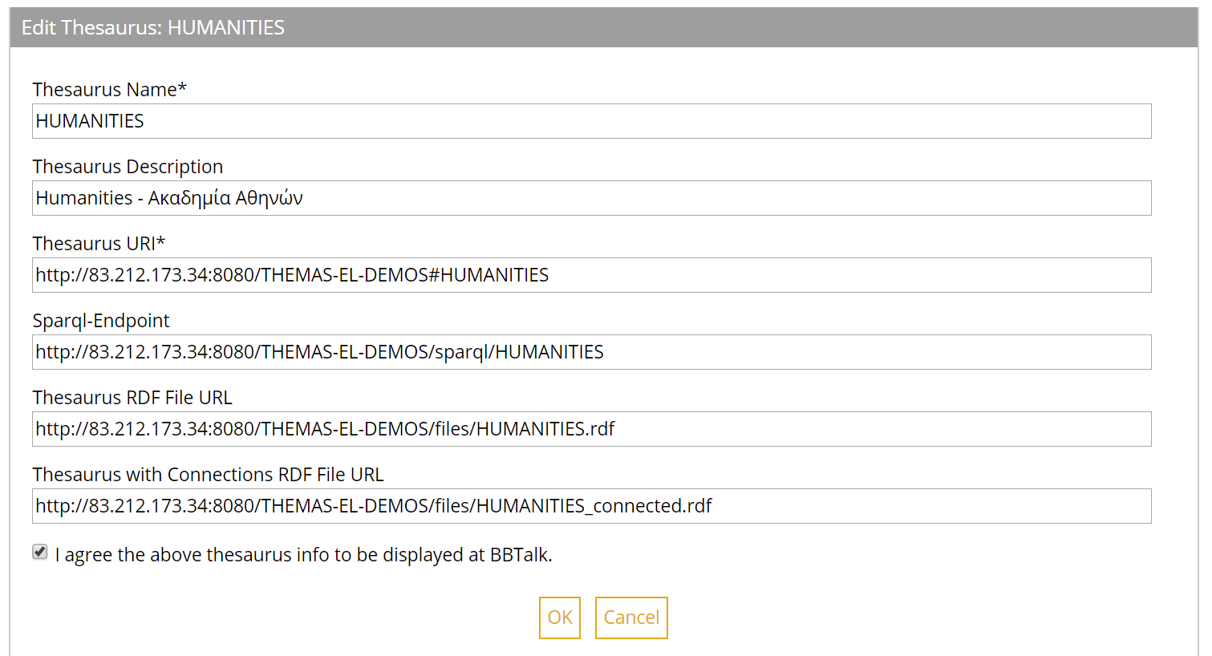
Figure 38: Thesaurus form

View a connection
Related user role: all (applies to all the section apart of paragraphs with other indication in the beginning)
When choosing a row of the table (which is a link to a specific Connection form) the Connection form in view mode opens up.
The Connection form page is divided in the following parts (described also in section “5.3.2 Create a new connection”):
- The top part which includes the breadcrumbs, the form title and the admin related Info, such as the username and the institution of the submitter of the connection, the date of the creation of the connection, the version of the BBT to which the referred BBT term belongs and the Connection Id etc.
- The main part of the page includes all the information about the connection. It contains the name of the BBT term and all the information that is related to the connected term of the local thesaurus (namely: connected term name, connected term URI, connected term relation to the BBT term).
- Finally, the bottom part that includes all the information that is related to the local thesaurus itself (namely thesaurus name, description, thesaurus URI relative RDF/SKOS files, etc.
At the bottom of the form are located action buttons related to the connection. Notice that actions depend on the ownership of the connection. The actions are discussed in detail in section “5.3.1.2 Connections actions”.
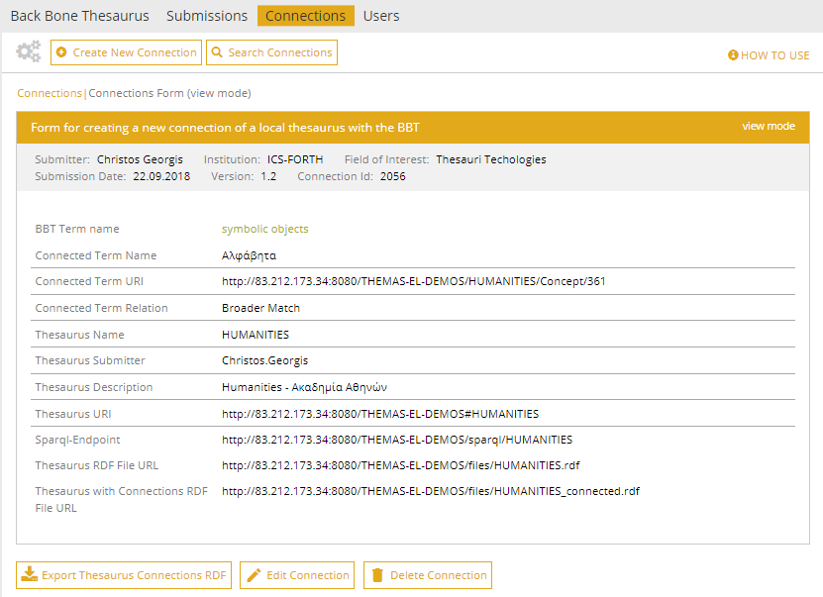
Figure 39: Connection form (view mode)

Edit a connection
Related user role: owner (applies to all the section apart of paragraphs with other indication in the beginning)
There are two ways the connection owner can edit a connection: (a) by selecting a connection in the table of connections and choose the “Edit Connection” button (Figure 35) on the right side of the table row (also described in section “5.3.1.2 Connections actions”) and (b) by selecting the “Edit Connection” button in the Connection form in view mode (Figure 39).
Notice that editable are only the connections owned by the user.
When the Connection form in edit mode appears, all fields are filled with information from the selected connection. A detailed description of the form can be found in section “5.3.2 Create a new connection”.

Search for connections
Related user role: all (applies to all the section apart of paragraphs with other indication in the beginning)
The user may search for a connection by adding the following criteria (Figure 40):
- BBT Term Name
- Connected Term Name
- Connected Term URI
- Connected Term Relation
- Thesaurus Name
- Connection Id
- Submitter
- Submission date
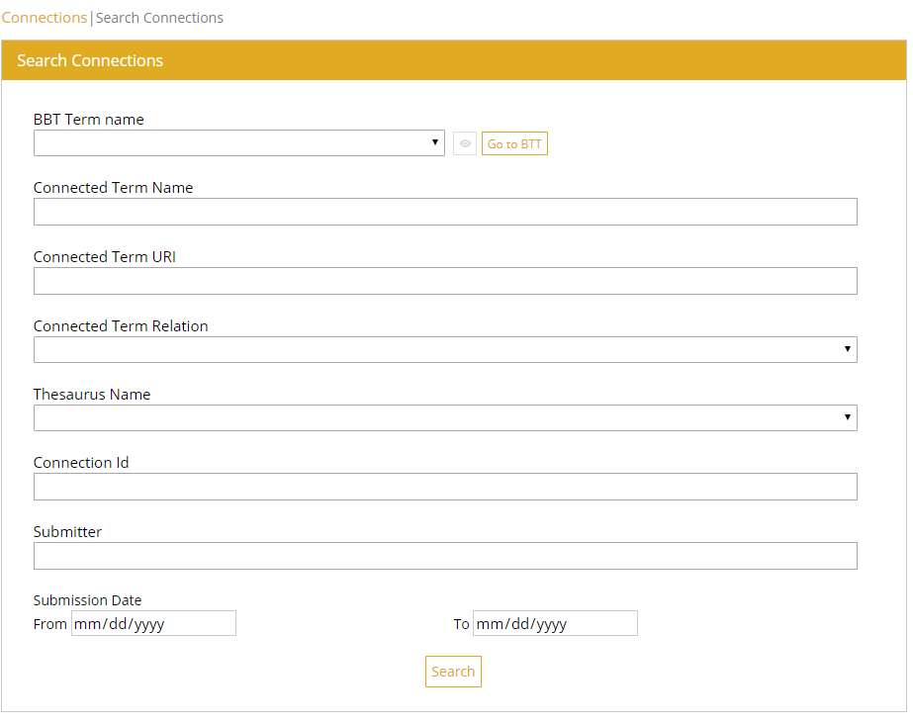
Figure 40: Connection Search Form

Exporting RDF files
Related user role: all (applies to the entire section apart of paragraphs with other indication in the beginning)
Connections made in BBTalk may be needed by the local thesauri maintainers to generate the RDF/SKOS file that contains the current version of the local thesaurus and the connections/mappings to related BBT concepts. This file is needed to be uploaded to BBT-browser, in order to keep the browser updated with the current version of the local thesaurus.
In order to facilitate this procedure BBTalk allows the user to export one or more connection(s)/mapping(s) from a specific local thesaurus to BBT concept(s) in an RDF/SKOS file (Figure 41). The file is then exported and downloaded. The content of this file can be appended into the RDF/SKOS file containing the current version of the local thesaurus.
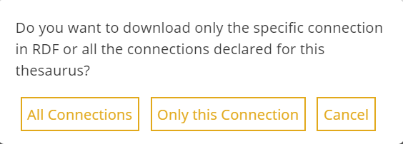
Figure 41: Exporting RDF files message

Create a new BBT version
Related user role: curator, administrator (applies to all the section apart of paragraphs with other indication in the beginning)
In this section, we describe how users can create a new BBT version, either from scratch, or by inspecting and implementing the submissions accepted for implementation, how users can preview the new “un-released” version, and finally how user can make a release of a new version public.
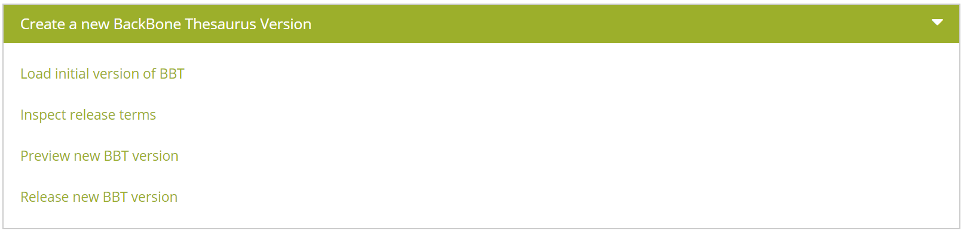
Figure 42: Create a new BackBone Thesaurus version - actions

Load initial version of BBT
Related user role: administrator (applies to all the section apart of paragraphs with other indication in the beginning)
The administrator can manually initialize the BBTalk database, by uploading a RDF/SKOS file containing the initial version of the thesaurus (BBT). This action initializes (deletes) also all submissions and connections stored in the database. Note that the RDF/SKOS file has to be compliant with the RDF/SKOS format used by the BBT. For this reason, the system provides an example of a valid thesaurus RDF file as a template (Figure 43).
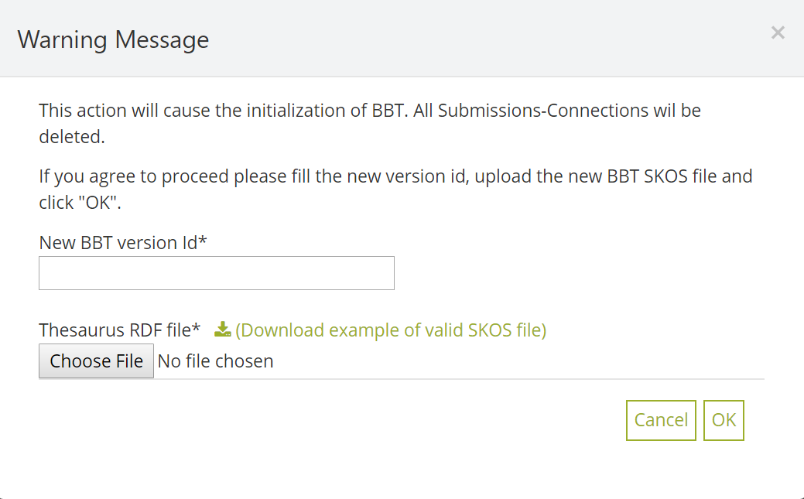
Figure 43: Load Initial Thesaurus upload form

Inspect release terms
Related user role: curator, administrator (applies to all the section apart of paragraphs with other indication in the beginning)
When the action “Inspect Release Terms” is selected, the list of all release terms submissions (submissions entries that are under status “accepted”) appears in the main area (Figure 44). Release terms submissions are listed by most recent entry date.
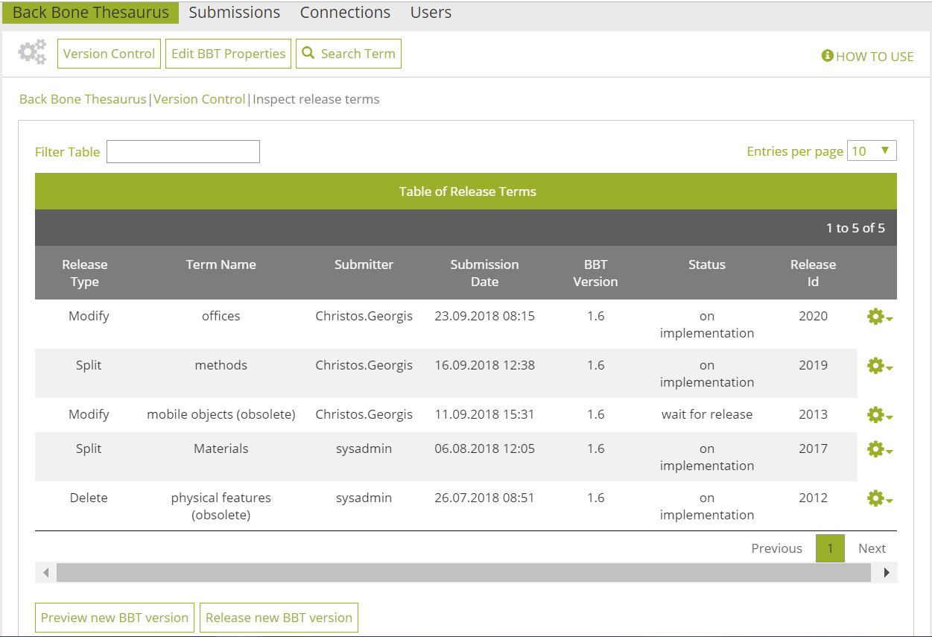
Figure 44: Release terms list results
Each line of the list represents a release term. Each column includes information related to the release term submission:
- Submission Type: the type of release term submission (e.g. proposal for splitting a term)
- Term Name: the term of the BBT the release term submission refers to
- Submitter: the user who made the release term submission
- Submission Date: the date of release term submission
- BBT Version: the version number of the BBT on which the release term submission was made
- Status: the status of the release term submission
- Submission Id: An identification number of the submission given automatically by the system
All release term submission lines of the list are links that lead to the Release form in view mode. The form is quite similar to the Submission form (see section “5.4.2.3 View a release term”).

Release terms list filters
Related user role: curator, administrator (applies to all the section apart of paragraphs with other indication in the beginning)
The user can filter release term submission from the filter box on the left top side of the list using keywords related to the field content that appears in the columns and rows of the table (Figure 45).
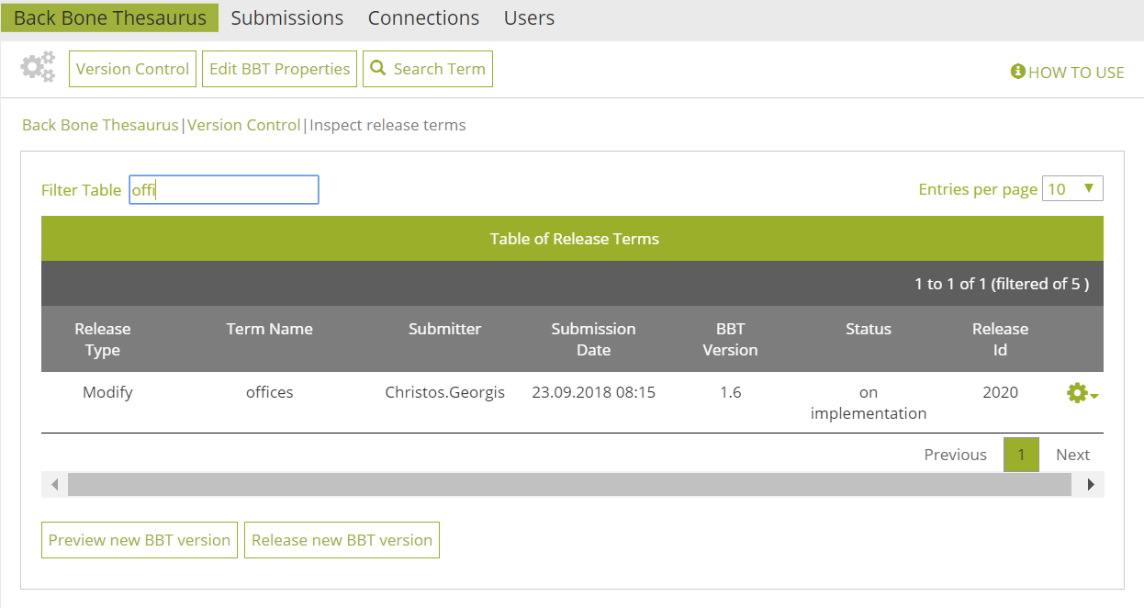
Figure 45: Release terms list results: filtered by keyword “offi”

Release term form Actions
Related user role: curator, administrator (applies to all the section apart of paragraphs with other indication in the beginning)
On the right side of each release term submission line are located the action buttons (Figure 46). Notice that actions depend on the status of the release term submission:
- Edit Release Term: this button opens the Release form in edit mode. Users can only edit the release term submissions status “on implementation”.
- Remove from release: this button allows the user to declare that the release term submission that was ready needs to get revised. The release term submissions status is changed from “wait for release” to “on implementation”. Now changes are allowed in this release term submission.
- Go to related BBT term or facet: this button allows the user to view the BBT term.
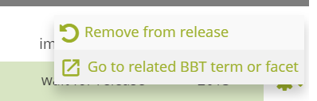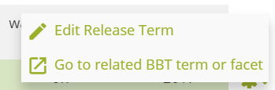
Figure 46: Release term form actions
Notice that the same set of actions is available from the Release form in view mode that is discussed in section “5.4.2.3 View a release term”.

View a release term
Related user role: curator, administrator (applies to all the section apart of paragraphs with other indication in the beginning)
The Release form in view mode (Figure 47) is quite similar to the Submission form in view mode (see section “5.4.2.3 View a release term”). The form includes all the information that is related to the BBT term. The fields depend on the submission type (splitting a term, delete a term etc.). These fields are described in detail in sections 5.2.3.2 to 5.2.3.6.
At the bottom of the form are located action buttons related to the release term submission. Notice that actions depend on the status of the release term submission. The actions are discussed in detail in section “5.4.2.2 Release term form Actions”.
By selecting “View Discussion” action the lower part of the Submission form (view mode) expands and reveals the discussion area.
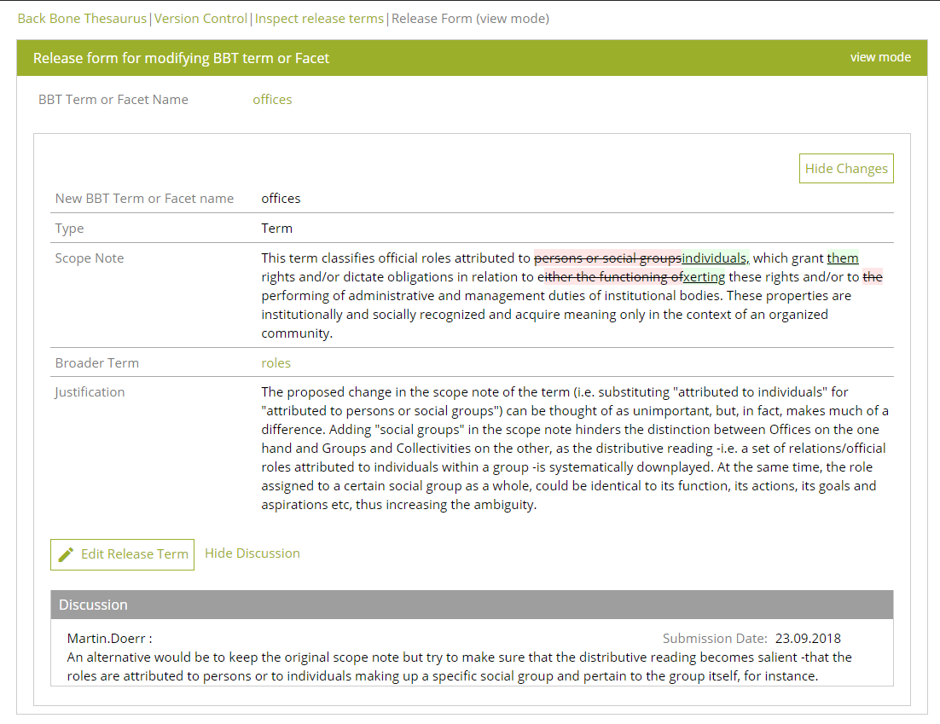
Figure 47: Release term form – view mode

Edit a release term
Related user role: curator, administrator (applies to all the section apart of paragraphs with other indication in the beginning)
The Release form in edit mode (Figure 48) is quite similar to the Submission form in edit mode (see section “5.2.8 Edit a submission”). The form includes all the information that is related to the BBT term. The fields depend on the submission type (splitting a term, delete a term etc.). These fields are described in detail in sections 5.2.3.2 to 5.2.3.6.
When the Release form in edit mode appears, all fields are filled with information from the original submission. The user has to open the submission discussion, by selecting “View discussion”, then manually collect the agreed information that was the result of the discussion and finally insert it in the various fields of the form accordingly.
By using this “Save” the release term submission is saved and its status remains “on implementation”. By using this “Add to Release” the user declares that the Release term is ready to be released in the new version of BBT. The release term submissions status is changed from “on implementation” to “wait for release”. No more changes are allowed in this release term submission.
Notice that editable are only the release term submissions with status “on implementation”.
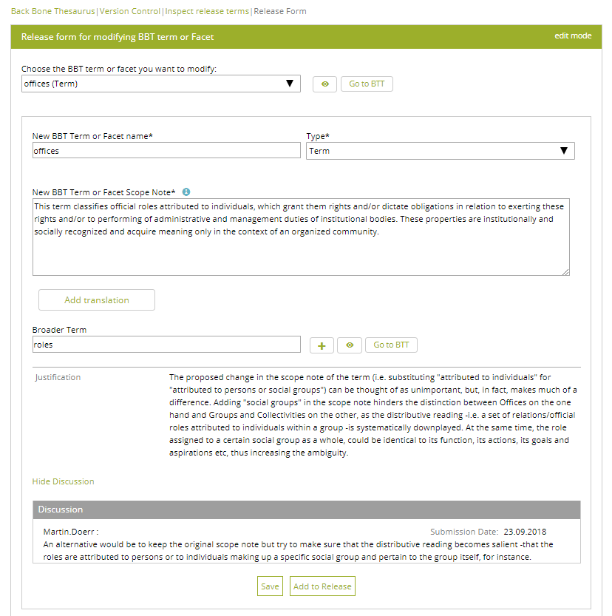
Figure 48: Release term form – edit mode

Preview new BBT version
Related user role: curator, administrator (applies to all the section apart of paragraphs with other indication in the beginning)
When the action “Preview new BBT version” is selected the tree of the proposed new (under implementation) of BBT appears (Figure 49). The layout of the tree is quite similar to the one described in section “5.1.1 BackBone Thesaurus – tree view”. “Facets” appear in a dark grey line, while the “top term” of the facet itself appear in a lighter grey line. All terms that belong under a facet (“hierarchies”), appear in a light colored line beneath the facet. All lines in the BBT tree are links that lead to the term forms.
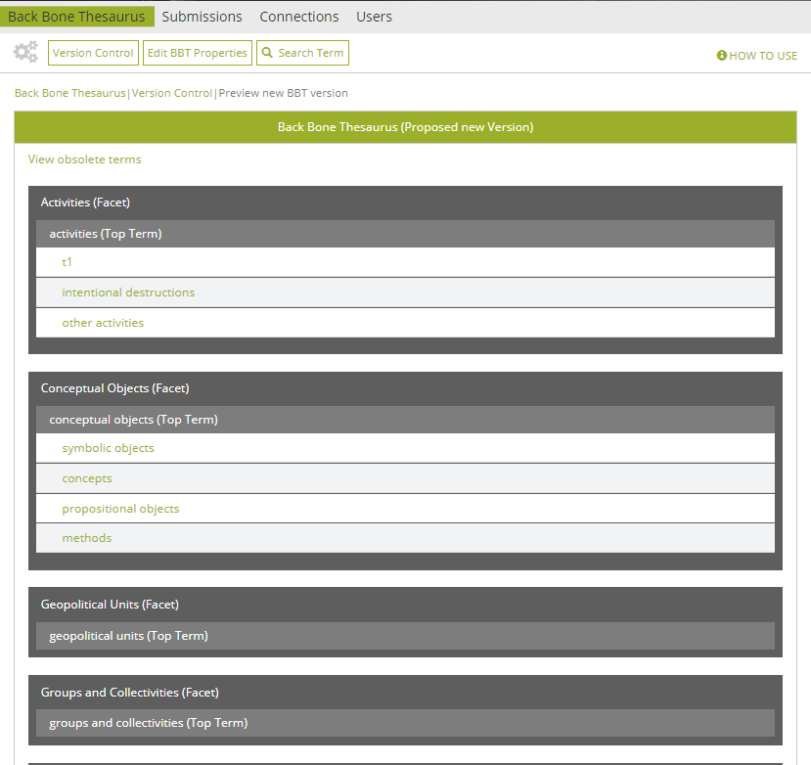
Figure 49: Preview new BBT version – tree view

Release new BBT version
Related user role: curator, administrator (applies to all the section apart of paragraphs with other indication in the beginning)
When the action “Release New BBT Version” is selected a new version of the BBT is about to get released, based on all release term submissions under status “wait for release”. A popup message appears prompting the user to provide a new number to the version that is about to be released (Figure 50). The release is taking place with user selecting OK button.
The release terms submissions under status on implementation will not be part of the new release and will stay in this status for future releases.
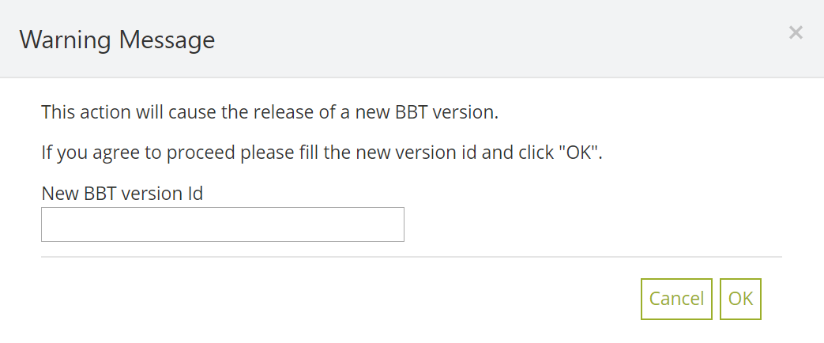
Figure 50: Release new BBT version message

Users
In this section we describe how users can edit their personal profile information and send messages to the administrator (Account Settings and Contact SysAdmin options of “User Account” section) and how the administrator may manage user accounts (Users tab-section).

View and edit user profile information
Related user role: all (applies to all the section apart of paragraphs with other indication in the beginning)
The upper right menu includes the “User Account” section with Account Settings, Contact SysAdmin and Logout options (Figure 51). By selecting Account Settings, the user can view and edit public and personal user information, using the Account Settings form.
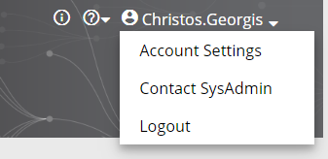
Figure 51: Account Settings option of the upper right menu
The Account Settings form (Figure 52) includes the following fields:
- Username: This field is taken automatically by the system and is not editable.
- Role: This field is taken automatically by the system and is not editable.
- Firstname and lastname: This information can be added by the user. This field is not obligatory.
- E-mail address: This field is taken automatically by the system and is not editable.
- Institution: This field may contain information about the institution of the user. This field is not obligatory.
- Field of interest: This field may contain information about the research interests of the user. This field is not obligatory.
All this information (excerpt Username) is considered personal information and is visible only to the user, to the curators, the reviewers and the administrators, or used by the system without public display.
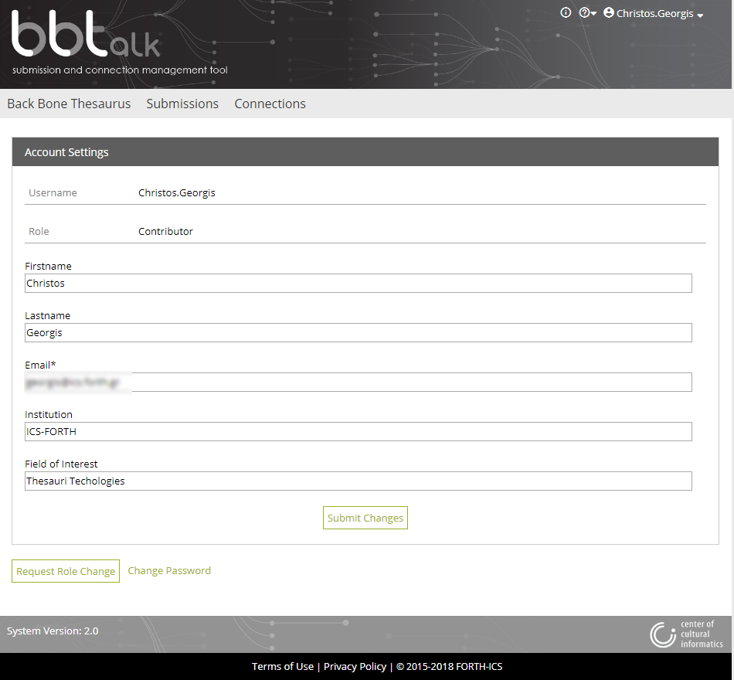
Figure 52: Account Settings form
The user can request to change his/her role by selecting the action “Request Role Change” in the lower left side of the form. This action opens up a pop up screen allowing the user to choose a role. This pop up screen contains the following fields (Figure 53Figure 54):
- Choose the new user role: The user may select one of the roles displayed. This field is obligatory.
- Message to the administrator: The user may type a message to the administrator in the text box to justify the reason for the role. This field is not obligatory.
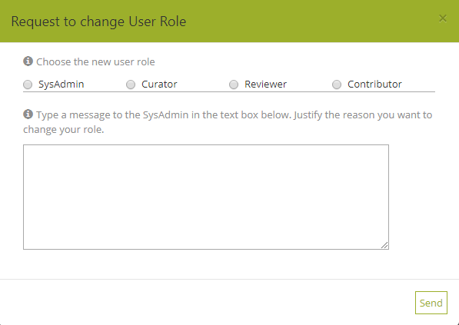
Figure 53: Request to change User Role pop up screen
The user can change his/her password by selecting the action “Change Password”. The Change Password form contains the following obligatory fields (Figure 54):
- Current password: The user should type his/her current password before changing it.
- New password: The user should add the new user password.
- Verify password: The user should verify that the new password is typed correctly.
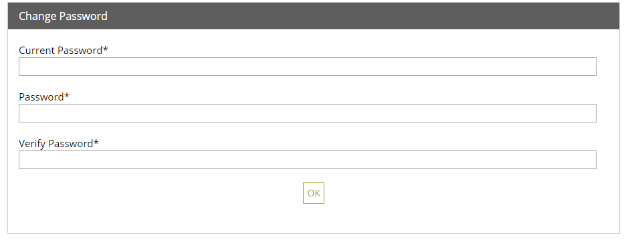
Figure 54: Change Password form

Contact the system administrator
Related user role: all (applies to all the section apart of paragraphs with other indication in the beginning)
The user can contact the administrator by selecting Contact SysAdmin option from “User Account” section (Figure 51). This action opens up a pop up screen allowing the user to write his/her message to the administrator (Figure 55).
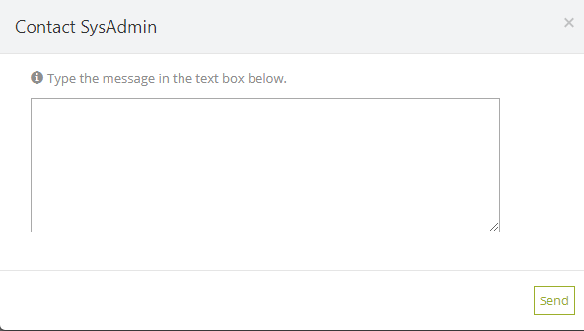
Figure 55: Contact Administrator pop up screen

Users list
Related user role: curator, reviewer, administrator (applies to all the section apart of paragraphs with other indication in the beginning)
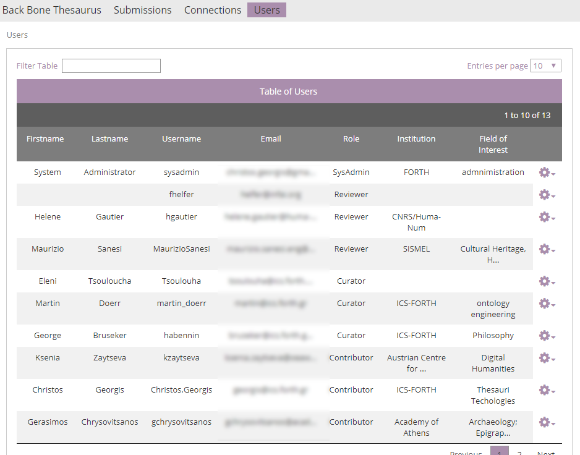
Figure 56: Users list
When the Users tab-section is selected (visible only to the curators, the reviewers, and the administrator), a list with all users appears with all relative information displayed: username, first name, last name, e-mail, filed of interest, etc. (Figure 56).
(Related user role: administrator) Only the administrator may select (Figure 57) to delete a user or assign a user with a different role (Figure 58).
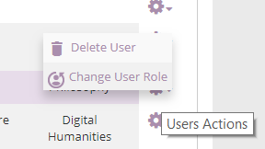
Figure 57: Users list actions, available only the administrator
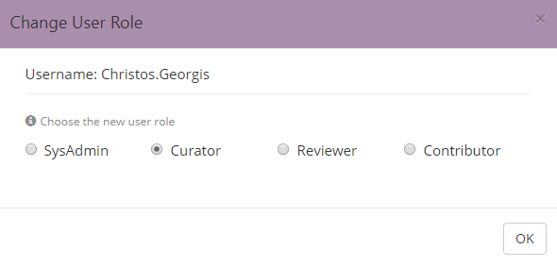
Figure 58: Change User Role

http://backbonethesaurus.eu
http://backbonethesaurus.eu/BBTalk
http://www.ics.forth.gr
The BBT-browser (also referred as BBT - Access Service) is a tool responsible for hosting and providing access to the current version the BBT. It provides consistent identification (LOD identification) for all terms of the BBT, in order to be referenced by the local thesauri. BBT - Access Service is based on Skosmos (http://skosmos.org) an open source tool, customized and maintained by ACDH-OEAW (www.oeaw.ac.at/acdh). Its current version can be accessed by clicking the link: https://vocabs.dariah.eu/backbone_thesaurus.
http://backbonethesaurus.eu/BBTalk/bbtFiles/BBT_official.rdf, http://backbonethesaurus.eu/BBTalk/bbtFiles/BBT_connected.rdf, http://backbonethesaurus.eu/BBTalk/bbtFiles/BBT_connected_thesauri.xml

