BBT –Submission and Connection Management tool

System Description

Produced by
Thesaurus Maintenance Working Group,
VCC3, DARIAH EU

Version 2.0 (draft)
Status: working document

November 2017
(last update: 11/11/2017)

Contributors: Christos Georgis, Martin Doerr, Evagelia Daskalaki, Ilias Tzortzakakis, Chryssoula Bekiari

Table of Contents
Table of Contents 2
Introduction 3
1 BBT - Submission and Connection Management tool 4
1.1 Users 4
1.2 System functionality 5
1.2.1 Navigate the BBT and its versions 5
1.2.2 Connecting local thesauri terms to BBT terms. 6
1.2.3 Receive and maintain suggestions on the BBT 7
1.2.4 Notifications about BBT releases 10
1.2.5 Integration with external systems 10
1.3 User actions 10
1.3.1 Contributors actions 10
1.3.2 Curators actions 11
1.3.3 Reviewers actions 11
1.3.4 Administrator actions 11
1.4 Submissions 11
1.4.1 Submission workflow 11
1.4.2 Submission statuses 12
1.5 Implementation details 14
1.5.1 System Architecture 14
1.5.2 System Platform 15
1.6 System Access 16

Introduction

In the report “Definition of a model for sustainable interoperable thesauri maintenance” , we propose a coherent overarching thesaurus for the humanities, a “backbone” or “metathesaurus”, under which all the vocabularies and terminologies in use in the domain can be aligned. The proposed approach is bottom-up; top-level terms are developed by adequate abstraction from existing local terminological systems.
In the design report "Assisting Backbone Thesaurus use and maintenance”, we describe how to support all the stakeholders in this endeavor, by proposing a maintenance methodology, along with an assisting toolset that:
- enables independent local thesauri maintainers to create and maintain their thesauri, and at the same time incorporate them while still maintaining their independence, into a shared common thesaurus, that will be available to the public,
- enables the curators of this common scheme of abstract terms (hereafter BackBone Thesaurus, or BBT), to support and maintain the BBT, as a central thesaurus which would provide the general terms under which local thesauri maintainers can link/connect their thesauri, and
- enables potential users (public, scientific community, etc.) to browse, navigate, visualize and use this very rich thesaurus that would incorporate the wealth of the different thesauri.
This document describes the methodology and tool (Submission and Connection Management tool) that enables independent local thesauri maintainers and potential BBT users (public, scientific community, etc.) to propose to the curators new BBT terms or modifications on the BBT existing terms, as well as assists local thesauri maintainers to use and link/connect their thesauri to BBT.

BBT - Submission and Connection Management tool
The BBT Submission and Connection Management tool is a communication system, developed by FORTH-ICS (www.ics.forth.gr), that supports discussions regarding the changes proposed for the BBT term, hereafter called submissions. It keeps track of the different versions of the BBT and the history of the submissions (related past discussions). It also notifies all the interested parties, about the progress of a submission, and the release of the new versions of the BBT.
The BBT Submission and Connection Management tool is used by local thesauri maintainers when they want to suggest changes for the BBT (contributors); it provides a form by which they can request modifications/additions/deletions regarding the terms of the BBT model. The tool is also used by the curators to browse and review submissions, and decide whether they agree to the suggested changes or disagree and reject/postpone them. The system also provides access to the previous versions of the thesaurus and the history of all the submissions in order to facilitate curator's job. The curators may also forward a submission to users that are experts in specific domains (reviewers), for further consultation. Finally, the tool is used by thesaurus Reviewers that take part on specific change-related discussions.
The BBT Submission and Connection Management tool also assists local thesauri maintainers to use and link their thesauri to BBT. As mentioned earlier publishing a new version of the BBT may also affect the local thesauri that are linked to BBT and therefore local thesauri maintainers need to be notified. The system provides (a) a service for creating (and removing) links originating from BBT terms to local thesauri terms (LOD identified), (b) a storage for contact info, along with (c) a notification mechanism that enables local thesauri maintainers to receive information on BBT new releases.

Users
The BBT Submission and Connection Management tool can be accessed only with a valid username and password. Depending on the user’s role, the user will have different rights. The different user-roles of the system are:
- Contributors: Contributors are persons who wish to comment or suggest changes on the BBT, requesting additions, deletions or modifications on the BBT terms and their relations. Contributors can also be local thesauri maintainers who wish to connect their local thesauri terms to terms in the BBT. Furthermore, contributor could be any person who is interested in browsing the BBT terms, their history of submissions and their connections with other thesauri terms.
- Curators: The curators are responsible for the maintenance of the BBT. Their role is to make changes to the thesaurus by consulting the submissions concerning the current and the previous versions of the thesaurus. They might also ask the consultancy of the thesaurus reviewers in order to take a decision about a specific change request.
- Reviewers: The reviewers review submissions forwarded by the curators that are pertinent to their expertise (domain of knowledge), and respond back to the curators with proposed changes to the BBT.
- System Administrators: The System Administrators are responsible for the maintenance of the system information and the system software: manage the new users, take and restore backups, etc.
The system provides a sign-in functionality, which enables anyone to login providing minimum communication information. Signed-in users get the role of contributor; to get a different role the user should contact systems administrator.

System functionality
The system provides navigation on the BBT and its versions, enables the connection of local thesauri terms to BBT terms, receives suggestions on possible changes in the BBT terms, while supporting the discussion on the suggestions and finally provides notifications about BBT releases on all the involved parties/users of the BBT.

Navigate the BBT and its versions
The BBT Submission and Connection Management tool provides browsing and navigation on the tree of BBT terms (see Figure 1). It provides forms that display term information (see Figure 2). The user can navigate the thesaurus by moving from term to term while is able from a single form to access the related submissions made for this specific term, all connected-terms from external thesauri to this specific term and the terms version history.

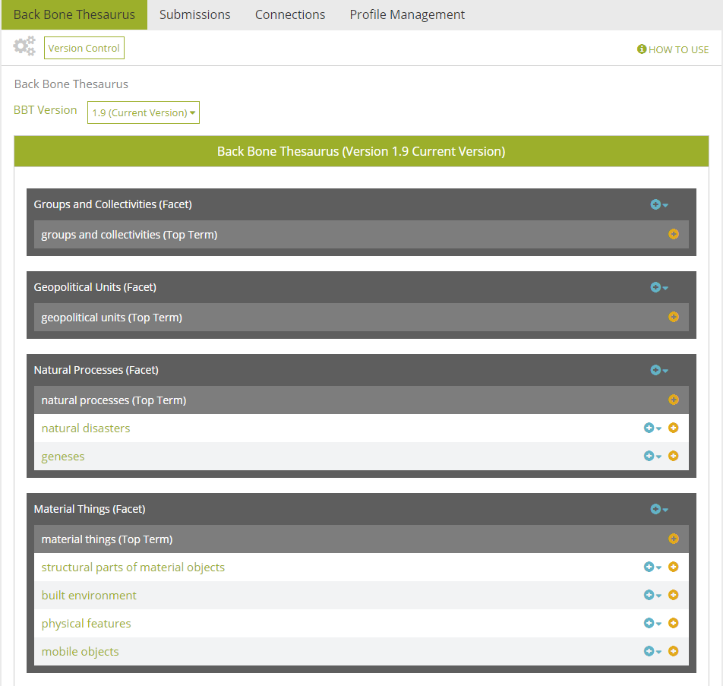
Figure 1: Back Bone thesaurus – tree view
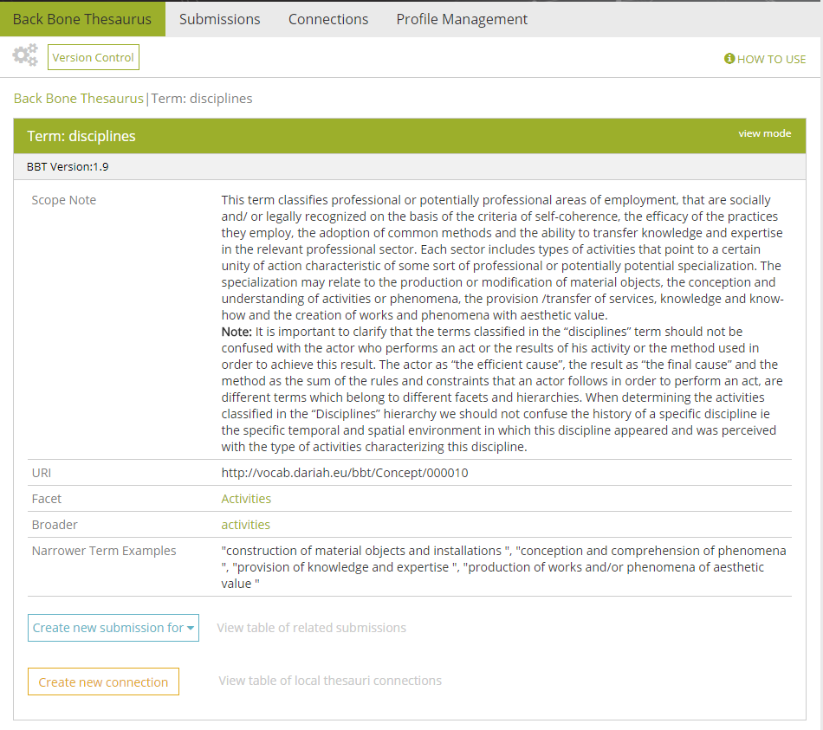
Figure 2: BBT Term form

Connecting local thesauri terms to BBT terms.
Local thesauri maintainers create their own local thesauri, using their own workflow and software. We encourage local thesaurus maintainers to use terms from BBT as top-terms in their thesauri. This will enable the alignment of their vocabularies and terminologies (thesauri) under one shared thesaurus, the BBT.
The first step in connecting local thesauri with the BBT in general means deciding which of the upper level terms of the local thesauri should be classified under the general terms of the BBT. We propose, that local thesauri maintainers should include in their local thesauri general BBT terms, by using local terms (declared as “same as”/“exact equivalence” or “narrower of” to the BBT terms, by their LOD identifiers as these are provided by the BBT Access Service). This would constitute a one-direction link/connection from the local thesaurus to the BBT.
Additionally we use the BBT Submission and Connection Management tool to maintain a second connection originating from the BBT term to its connected term in the local thesauri. The system provides a form (see Figure 3) which enables local thesaurus maintainers to create this connection (LOD identification of the local thesaurus term which is declared as “same as” or “narrower of” the BBT term). The system also stores contact information of the local thesauri maintainers in order to keep them updated for changes on the specific BBT term (e.g. contact e-mail, organization info, etc.). This information is initially received during the user signing-in phase and can be later updated by the user.
The BBT Submission and Connection Management tool also includes a service that notifies the local thesauri maintainers about changes in the new version of BBT that may affect them. For instance, if a BBT term is modified (e.g. its scope note is updated, thus its meaning is altered), all local thesauri developed that are connected to the specific BBT term as a top-terms in their thesauri, should be notified about the change in order to verify if the specific change affects their local thesauri.
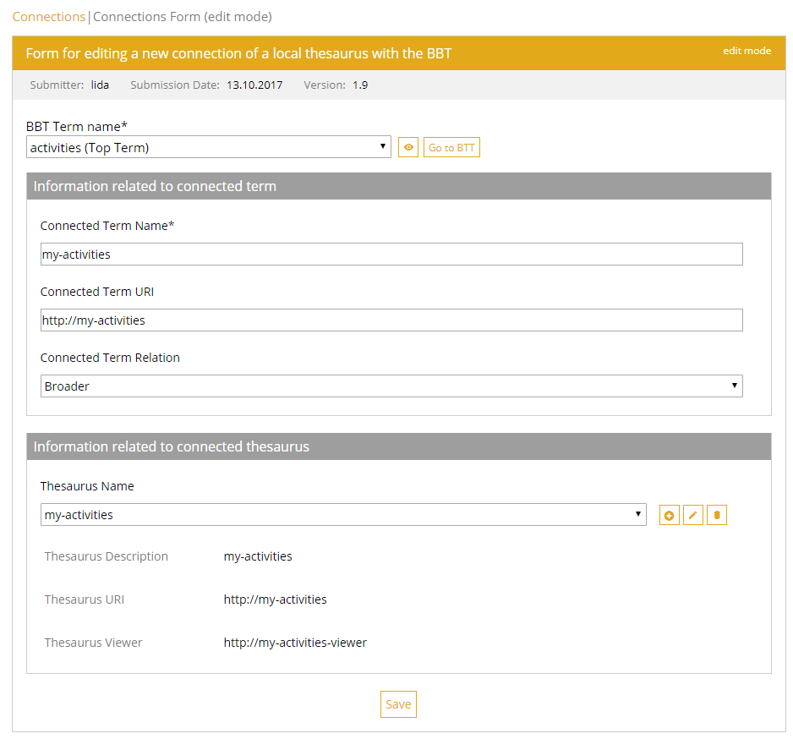
Figure 3: Connection form
Local thesauri maintainers may also decide to disconnect their thesauri from BBT. For that, they should remove the local connections declared as “same as” or “narrower” to the BBT terms (removal of the one-direction link/connection from the local thesaurus to the BBT). Additionally they should use the BBT Submission and Connection Management tool to remove the connection originating from the BBT term to its connected term in the local thesauri (and maybe would also remove the related local thesauri maintainers contact information).

Receive and maintain suggestions on the BBT
The BBT Submission and Connection Management tool also receives requests (submissions) from users who want to suggest changes on the BBT model (contributors) and assists the curators in making decisions about these requests, by providing full version control on the BBT and on the submissions. It provides access to the current state of the thesaurus, all BBT previous versions, maintaining all their differences from version to version and finally provides access the history of all submissions.
It provides contributors with forms for sending requests for modifications/additions/deletions on specific terms or specific relations of the BBT model (see Figure 5). The curators can browse through the submissions, review them and decide whether they agree to accept the suggested change or disagree and reject or postpone the change. To assist them in making their decisions the system provides the previous versions of the thesaurus and the history of all the submissions ever made in order to facilitate the work of curators. In Figure 4, we present the Use Case diagram for the submission process. The submission workflow and coordination is described in detail in section 1.4.1.

Figure 4: Use Case diagram for the Submission

The curators use the BBT management tool to implement the actual changes in the thesaurus database. After several minor or few major changes of the BBT model, a release of the BBT may be decided by the curators.
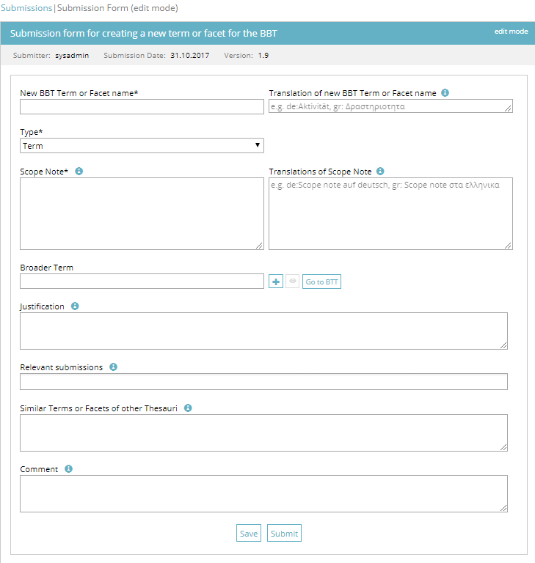
Figure 5: Submission form for creating a new BBT term
As a new version is created, all changes between the new and the previous version of the thesaurus are semi-automatically tracked (some of the changes may need to be manually identified by the curator). Now all past submissions follow the current version of the BBT. The mechanism described above enables the system to provide access to the previous versions of the thesaurus, the differences between versions and the history of all the submissions.
The BBT Submission and Connection Management tool provides contributors with automatic feedback (email notifications) regarding the status of their submission and the status of the BBT: a new version of the thesaurus (a submission is made) is about to be (or is) released.

Notifications about BBT releases
The BBT Submission and Connection Management tool includes a service that notifies the local thesauri maintainers about changes in the new version of BBT that may affect them. For instance, if a BBT term is modified (e.g. its scope note is updated, thus its meaning is altered), all local thesauri developed that are connected to the specific BBT term as a top-terms in their thesauri, should be notified about the change in order to verify if the specific change affects their local thesauri.
Furthermore, the system provides all contributors with automatic feedback (email notifications) regarding the status of their submission and the status of the BBT: a new version of the thesaurus (a submission-request is implemented) is about to be (or is) released.

Integration with external systems
The system is designed to be customized to support interaction with other external tools, by using web services technology, which allows the systems to communicate with each other without intimate knowledge of each other’s internal behaviour or technology.
A sample of the customizable functions that the system provides via web services are listed below:
- Add a new submission into the system
- Return the table of differences between two subsequent versions, as the curator has marked them
- Return the history of a term (all the term differences from version to version)
- Receive a new BBT version and automatically load it into to the system.
We welcome any suggestions for additional functions or customizations on the existing ones.

User actions
By using the BBT Submission and Connection Management tool the contributors are able to search for a term or a facet in the BBT, to search for other submissions or connections and create a new submission or a new connection. The system stores the history of the dialogue between the contributors, the curators and the reviewers and inform all the interested parties when a change on the thesaurus has occurred or a new version of the thesaurus has been released. All the interested parties are kept up to date, by receiving e-mail from the system. Furthermore, the system assists local thesauri maintainers to use and connect their thesauri to BBT.
The functionalities of the system for each of the user-roles are the presented in the following sections.

Contributors actions
The contributors have the following functions:
- List all terms and facets in the BBT
- Search for a term or a facet
- View term or facet details
- View the history of a term
- Submit a request for change in the BBT model. The contributors can create a submission for adding, deleting, modifying a term or a facet, for merging or splitting terms in the BBT model. The system provides a form where the user has to fill in the necessary information: term(s), scope note(s), context of use, justification and example.
- List all submissions
- Search for submissions
- View submission details
- Reply to a comment from a curator or a reviewer on a submission
- List all connections from BBT to all local thesauri
- Search for connections from BBT to all local thesauri
- Create (or delete or modify) a connection from a BBT term to a local thesauri term

Curators actions
The curators have all the functions available to the contributors as well as:
- Initiate, take part (add comments) and close the discussion on a submission
- Invite reviewers on a submission
- Invite a contributor to take part on specific parts of the discussion (e.g. request for clarification or explanation)
- Change the status of a submission
- Insert a new Version of the BBT history

Reviewers actions
The reviewers have the same functions as the contributors, as well as:
- Take part (add comments) on a submission, after invitation from a curator
- Invite a contributor to take part on specific parts of the discussion (e.g. request for clarification or explanation)

Administrator actions
The administrators have the same functions as the curators, as well as:
- Manage the users accounts
- Manage submissions and connections

Submissions

Submission workflow
When inserting a new change request (submission) into the system the contributor receives automatic response that certifies the submission. Once this is done, the new submission is inserted into the system’s submission pool. Notifications on the new submissions are sent by e-mail to the curators, in order to inform them for the new change requests. Furthermore, the curators can see the new submissions in the system in their system workspace. The process that is followed after a new submission is described below:

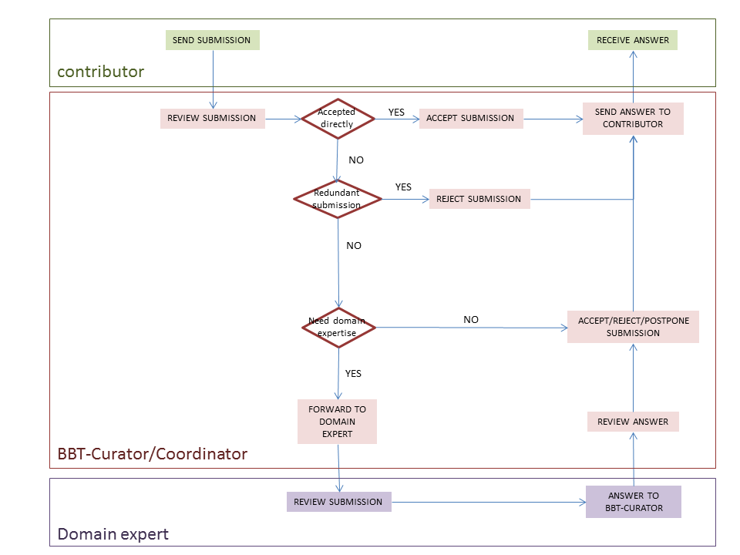
Figure 6: Activity Diagram of the submission workflow
When the new submission is inserted, the curators may check whether the submission is redundant, or not, and initiate the discussion on the proposed change, by welcoming the other curators to review the new submission. If the submission is directly accepted, one of the curators implements the change into the BBT database using the BBT Management Tool. Otherwise the submission is rejected, postponed or beyond curators’ expertise. If the curators consider that the submission is beyond their expertise, they may send it to a reviewer (invite him/her in the discussion). The reviewer will be informed by e-mail for the submission. After the reviewer checks the submission, he/she state his/her opinion on the change. The curators review the reviewer’s answer, and again decide to accept, reject, or postpone the submission. In all cases the contributors are informed by e-mail about the progress of their submissions. In Figure 6, above, you can see the activity diagram of the submission workflow. Although it is not presented in the diagram, a discussion may contain many iterations of discussions. A curator may end the discussion (e.g. concluding that a common agreement is reached or by asking a voting to take place, etc.).
The curators are also responsible to decide upon the publication of a new version of BBT model: a new version of BBT may include several changes of the BBT. In order for an official version of the BBT model to be released, the curators use the BBT Management Tool to implement any pending changes in the thesaurus database, as mentioned above. Then they export official version of the BBT model from the BBT Management Tool in two forms: the BBT Definition Document (the official textual description of the BBT model) and the BBT LOD model (a SKOS RDF document). The new version of BBT LOD model should be sent to the BBT – Thesaurus Access tool to be loaded and to be publicly accessible (by the BBT access providers).

Submission statuses
Submissions have statuses that can be changed by the selected user actions. They are listed below (see also Figure 7):
- saved: The contributor may save a submission, without submitting it. Submissions that have been saved and not submitted are registered as “saved”. Only the contributor sees his saved submissions and he may also delete them.
- submitted : Once the contributor sends a submission, the submission takes the status “submitted”. This status shows that the submission has not yet been checked from the curator. The contributor may delete his submission or change its status back to “saved” to be able to update his submission.
- under discussion: After the submission is sent, the curator checks the submission and starts the discussion with other curators about the submission by adding comments to the submission. Now the submission is on a discussion-track and cannot be updated or deleted.
There is a case that he might need some explanations or even more information about the submission. If that is the case, then he sends a submission back to the contributor or a reviewer. The contributor or the reviewer reviews the received submissions and replies giving explanations or more information about the submission.
- (accepted) on implementation: When a submission has the status “on implementation”, means that the change request is in the phase of implementation.
- (accepted) wait for release: After the implementation is completed, the curator changes the submission status to “wait for release”. Now no more comments may be added to the submission.
Notice that the contributors see the above two statuses as “accepted”.
- postponed: The request for change will be reviewed later in time.
- rejected: The request for change is considered as not implementable and all the parties are informed.
- released: When a new official version of the BBT model is released, all submissions with status “wait for release” change to “released” and all the interested parties are informed about the final status of the request for change.
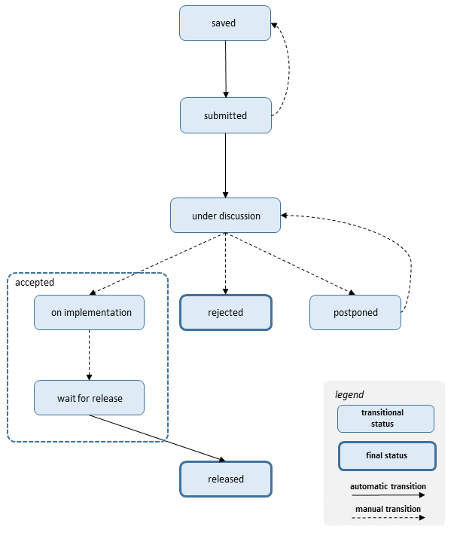
Figure 7: Sequence Diagram of submission statuses

Implementation details

System Architecture
The system is developed on a 3-tier architecture, which allows us to create a modular code that can be easily maintained and expanded.
Storage management
The storage management module includes a XML Database where all the RDF files of BBT versions, XML term definition files (one for each term), the XML submission files, the XML files describing the connections and related local thesauri, as well as the XML files for user profiles and their local thesauri information. The system stores all the versions of the BBT; each version of the BBT includes the thesaurus information in an RDF (SKOS) document and the XML term definition files (one for each term) that contain the description of terms and relations between terms.
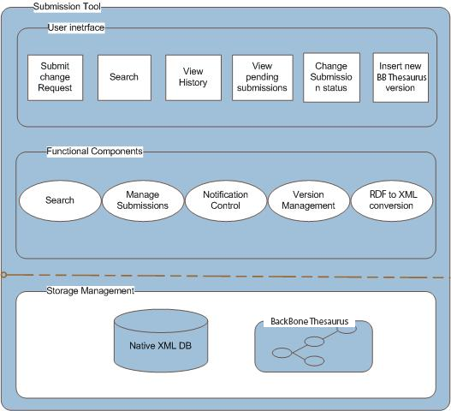
Figure 8: System Architecture
User interface
The user interface includes the interaction components that contributors, curators and reviewers use for the change requests, along with change-request reviewing and thesaurus versioning reviewing and the search. Notice that the actions provided to the users depend on the users’ role. This front-end of the system provides users with clear view of the operations available for the specific documentation stage. The system’s functionality is invoked with simple user actions, such as button selections etc.
Functional components
The functional components constitute the basic mechanism that incorporates all the system’s intelligence. It includes various functional modules such as the search mechanism for the submissions, search mechanism for the Terms, the mechanism for adding a new submission, the permissions management component, the notification control mechanism, the version Management component, the RDF to XML conversion module, etc. These modules are invoked by user actions or through the interaction with other modules and react with the storage mechanism.

System Platform
Web Application Server and Web-browser
The Submission and Connection Management tool is a web based on-line application, which is based on client-server architecture. As mentioned earlier, the system is developed using J2EE technology, on a 3-tier architecture, which allows us to create modular code that can be easily maintained and expanded. It is accessible to every user who owns a login account. The only prerequisite for using the tool are access to the World Wide Web (Internet) and a Web Browser (e.g. Internet Explorer, Mozilla Firefox, etc.).
Database
We have chosen eXist Native XML DB, as our system XML database. The choice has been made based on the following criteria: open source, documentation, reputation, encoding support, interface capability with other systems.
Operating system
The Submission and Connection Management tool Application Server is developed and operated on a Windows Operating system, but we expect to run smoothly on any operating system since the underlying technologies are running on any operating system.

System Access
- Web Application http://backbonethesaurus/SCMT

For more details, please contact daskalak@ics.forth.gr or georgis@ics.forth.gr.

“Definition of a model for sustainable interoperable thesauri maintenance”, produced by Thesaurus Maintenance Working Group, VCC3, DARIAH EU, Version 1.2, September 2016, (http://backbonethesaurus.eu/sites/default/files/DARIAH_BBT%20v%201.2%20draft%20v4_0.pdf)
“Assisting Backbone Thesaurus use and maintenance”, produced by Thesaurus Maintenance Working Group, VCC3, DARIAH EU, Version 2.0, March 2017, (http://backbonethesaurus.eu/sites/default/files/assistingbackbonethesaurusmaintenance_v2.0_draft.pdf)
Note that the BBT Submission and Connection Management tool does not replace the BBT Access Service (https://vocabs.dariah.eu/backbone_thesaurus), which is responsible for hosting and providing the web-presence and LOD access to the current version the BBT.
This linking/connection of the local thesaurus with the BBT is performed by the local thesaurus maintainers using their own thesaurus maintenance workflow and software.
BBT Access Service (https://vocabs.dariah.eu/backbone_thesaurus) provides consistent identification (LOD identification) for all concepts of the BBT, in order to be referenced by the local thesauri. It is based on Scosmos (http://skosmos.org) an open source tool customized and maintained by ACDH-OEAW (www.oeaw.ac.at/acdh).
The current BBT management tool, is based on THEMAS system (http://www.ics.forth.gr/isl/THEMAS), an open source Web based system for creating, managing and administering multi-faceted multilingual thesauri according to the principles of ISO 25964-1 and ISO 25964-2 standards, developed by FORTH-ICS (www.ics.forth.gr).

